

Cardiff Metropolitan University

**SMART HEALTH DISEASE PREDICTION SYSTEM “QuickDoc”**

Submitted in October 2022

By

**R.M. Lahiru Niranjan**

(Student ID - [**st20225019**] – [**NG/BSCSD/06/05**])

*This dissertation is submitted in partial fulfillment*

*Of the requirements for the degree of*

**BSc (Hons) Software Engineering**

**DECLARATION**

This work is being submitted in partial fulfillment of the requirements for the degree of

BSc (Hons) Software Engineering and has not previously been accepted in substance for any degree and is not being concurrently submitted in candidature for any degree.

Signed - Lahiru Niranjan (Candidate)

Date - 21/10/2022

**SUPERVISOR’S DECLARATION STATEMENT**

Student Name - R.M. Lahiru Niranjan

Supervisor’s Name - Ms. Chamila Attanayaka

I acknowledge that the above-named student has regularly attended the meeting, and actively engaged in the dissertation supervision process.

Signed - ……………………………………………. (Supervisor)

Date - …………………......



**Cardiff Metropolitan University**

**Assignment Cover Sheet**

|  |  |  |  |  |  |  |  |  |
| --- | --- | --- | --- | --- | --- | --- | --- | --- |
| **Student Details** | | | | | | | | |
| Name | | | **Lahiru Niranjan(st20225019)** | | | | | |
| Student ID | | | **NG/BSCSD/06/05** | | | | | |
| **Scheduled unit details** | | | | | | | | |
| Unit code & Title | | | CIS6002 Software Engineering Dissertation Project | | | | | |
| Unit enrolment details | | | Year | |  | | | |
| Study period | |  | | | |
| Lecturer | | | Ms. Asanki Fernando | | | | | |
| Mode of delivery | | |  | | | | | |
| **Assignment Details** | | | | | | | | |
| Topic | | |  | | | | | |
| Learning Outcomes | | |  | | | | | |
| Word count | | |  | | | | | |
| Due date | | | WRIT 06th October 2022  Presentation 08th October 2022 | | | | | |
| Extension granted? | | | Yes | No | Extension Date | |  | |
| Is this a resubmission? | | | Yes | No | Resubmission Date | |  | |
| **Declaration** | | | | | | | | |
| I certify that the attached material is my original work. No other person’s work or ideas have been used without acknowledgement. Except where I have clearly stated that I have used some of this material elsewhere, I have not presented it for examination / assessment in any other course or unit at this or any other institution | | | | | | | | |
| Name/Signature | | | **Lahiru Niranjan** | | | Date |  | |
| **Submission** | | | | | | | | |
| Return to: | | |  | | | | | |
| **Result** | | | | | | | | |
| Marks by 1st Assessor |  | Name & Signature of the 1st Assessor | | |  | | | **Agreed Mark** |
| Marks by 2nd Assessor |  | Name & Signature of the 2nd Assessor | | |  | | |
| **For Office use only (hard copy assignments)** | | | | | | | | |
| Receipt date |  | Received by | | |  | | | |

**CMU BA (HONS) BMS - ASSIGNMENT FEEDBACK PERFORMA –ICBT CAMPUS**

|  |  |  |  |  |  |  |
| --- | --- | --- | --- | --- | --- | --- |
| **STUDENT NAME:  *Lahiru Niranjan Ranathunga*** | | | | **STUDENT NUMBER: NG/BSCSD/06/05** | | |
| **Module Number & Title**: Software Engineering Dissertation Project | | | | **Semester:** | | |
| **Assignment Type & Title:** | | | | | | |
| **For student use: *Critical feedback on the individual progression towards achieving the assignment outcomes*** | | | | | | |
|  | | | | | | |
| **For 1st Assessor use: Assessment feedback** | | | **For 2nd Assessor use: Assessment feedback** | | | |
|  | |  | | | | |
| **Areas for future improvement** | | | | | | |
| **Name & Signature of the 1st Assessor :** |  | | | | **Date :** |  |
| **Name & Signature of the 2nd Assessor :** |  | | | | **Date :** |  |
| **Comments by the IV** | | | | | | |
| **Name & Signature of the IV:** |  | | | | **Date :** |  |

# Plagiarism Report

# Abstract

The report is divided into nine chapters. Each chapter covers different aspects of **QuickDoc**. Chapter 1 deals with the introduction; It places more emphasis on the purpose of creation. It also provides different goals and objectives of the project. Chapter 2 focuses on the review of the literature on existing systems, in particular the advantages and disadvantages. Also provides optimal resolutions to the disadvantages of traditional systems.

Chapter 3 provides an overview of the complete planning of the project, from scratch to completion. It describes the roles assigned to the different members of the group and their methodological approach to the project. It also gives an idea of the budget, constraints and timeline. Chapter 3 is also included Software Requirements Specification. It describes what the software will do and how it will be expected to work. It also describes the features that the product needs to meet the needs of all stakeholders. It explains in depth the functional and non-functional requirements and the design of the system, it provides more details and classification of the system design. It explains the overall system architecture of the interface and more about it and also chapter 3 consists of various screenshots of the system including its various features, basic operation, operations and many other features.

Chapter 4 provides the implementation of the project in different pieces or modules, classified differently. It explains the implementation of various ML algorithms in our system to acquire the highest accuracy. It describes the development of the system using various languages, libraries, frameworks, databases, and ML algorithms. Chapter 5 discusses testing the system using various test cases to retrieve accurate predicted results. It also provides various sets of actions performed to verify a particular feature or feature of our system. Chapter 6 concludes on the project and gives more substance on the future scope of our system in various ways. This chapter summarizes the whole project with better prospects.

# Acknowledgment

I must express my sincere gratitude to the best individual who helped and guided me in completing this task. I will always remember to appreciate them for their assistance and direction in anything I do. I want to thank Ms. Chamila Attanayaka and Ms. Asanki Fernando for providing me with a good guide to assign after numerous talks. I owe them a huge debt of gratitude for all of his help and direction.

Additionally, I would want to express my gratitude to ICBT and Cardiff Metropolitan University for giving me the chance to complete this assignment.

And I couldn't finish this without at least a little assistance from my friends. So, a sincere thank you, and last but not least, my appreciation to the family members for their direct and indirect assistance in helping me successfully complete my task.

# Table of Contents

Plagiarism Report 7

Abstract 8

Acknowledgment 9

Table of Contents 10

Table of Figure 11

Table of tables 12

Chapter 1 13

1.1 Introduction 13

1.2 Current situation leading to problem identification 14

1.3 Purpose 14

1.4 Proposed technique to solve the current problem 14

1.4.1 Project Scope 14

1.4.2 Project Goals and Objectives 15

Goals 15

Objectives 16

1.5 Project Timeline 17

Chapter 2 18

Literature Review 18

2.1 Designing Disease Prediction Model Using Machine Learning Approach 18

2.1.1 Advantages of Paper 18

2.1.2 Disadvantages of Paper 18

2.1.3 How to overcome the problems mentioned in Paper 19

2.2 Data Mining and Machine Learning for Symptom-Based Health Prediction 20

2.2.1 Advantages of Paper 20

2.2.2 Disadvantages of Paper 20

2.2.3 How to overcome the problems mentioned in Paper 21

2.3 A new approach to predict diabetes using the naïve Bayesian classifier 22

2.3.1 Advantages of Paper 22

2.3.2 Disadvantages of Paper 22

2.3.3 How to overcome the problems mentioned in Paper 23

2.4 Technical Review (Implementation Type) 24

2.4.1 Benefits of technology 24

2.4.2 Reasons to use this technology 24

Chapter 3 25

System Analysis and Design 25

3.1 Project Management Approach 25

3.1.1 Roles and responsibilities 26

3.1.2 Assumptions and Limitation 27

3.1.3 Feasibility Studies 28

Operational Feasibility 28

Technical Feasibility 28

Economic Feasibility 29

Schedule Feasibility 29

3.1.4 System Requirements Definition 30

Functional requirements 30

Data-flow Diagram 32

3.2 System Architecture Design 36

3.2.1 Sub-system Development 36

Registration Module 37

Data Collection Module 37

Disease Prediction Module 38

Web Module 38

3.3 Systems Integration 39

3.3.1 Component Diagram 39

3.3.2 Class Diagram 40

3.3.3 Sequence Diagram 41

3.3.4 Deployment Diagram 42

3.4 Screenshots of User Interfaces 43

3.4.1 Home Page 43

3.4.2 Dashboards 43

3.4.3 Disease Prediction 45

3.4.4 Consultation History 46

3.4.5 Live Consultation 46

Chapter 4 47

Data Analysis and Discussion 47

4.1 Product Perspective 47

4.1.2 Product Features 47

User Classes and Characteristics 47

Operating Environment 48

Design and Implementation Constraints 48

4.2 System Features 49

Accurate Prediction with faster results 49

Live Consultation 49

Patient’s Health Care 49

4.2.1 Resources required: 50

Technologies used in the system 50

Software Tools 50

4.2.2 Non-functional Requirements 50

Performance Requirements 50

Safety Requirements 50

Security Requirements 50

4.3 Implementation 51

4.3.1 Approach 51

4.3.2 Disease Prediction 52

4.3.3 Machine Learning Module 53

4.3.4 Comparing the test accuracy of different classifier models 58

4.3.5 Live Consultation Module 59

Chapter 5 61

Evaluation and Testing 61

5.1 Testing 61

5.1.1 Black Box Testing 61

5.1.2 White Box Testing 61

5.1.3 Unit Testing 62

5.2 Test Plan 62

5.3 Test Cases 65

Chapter 6 81

Conclusion and Future Work 81

6.1 Conclusion 81

6.2 Future Scope 82

Appendices 83

References 85

# Table of Figure

Figure 1: Effective and Accurate Prediction 18

Figure 2 : Reduce Anxiety 18

Figure 3:consulting Doctors 19

Figure 4:Live Consultation 19

Figure 5:Use case Diagram For QuickDoc 34

Figure 6:DFD Level 0 for QuickDoc 35

Figure 7:DFD Level 1 for QuickDoc 35

Figure 8:DFD Level 2 for QuickDoc 36

Figure 9: Activity Diagram for QuickDoc 37

Figure 10:System Architecture Design Diagram for QuickDoc 39

Figure 11:Registration Module 40

Figure 12:Data Collection Module 40

Figure 13:Disease Prediction Module 41

Figure 14:Web Module 41

Figure 15:Component Diagram for QuickDoc 42

Figure 16:Class Diagram for Smart Health Disease Prediction System 43

Figure 17:Sequence Diagram for Doctors 44

Figure 18:Sequence Diagram for Patients 44

Figure 19:Deployment Diagram 45

Figure 20:Home Page UI 46

Figure 21:Doctor Dashboards UI 46

Figure 22:Patient Dashboards UI 47

Figure 23:Admin Dashboards UI 47

Figure 24: Disease Prediction UI 48

Figure 25:Disease Prediction UI 48

Figure 26:Consultation History 49

Figure 27:Live Consultation 49

Figure 28:Symptoms Addition Module 55

Figure 29:Logistic Regression 56

Figure 30:K - Nearest Neighbor 57

Figure 31:Kernel - Support Vector Machine 58

Figure 32:Naïve Bayes 59

Figure 33:Decision Tree 60

Figure 34:Comparing the test accuracy of different classifier models 61

Figure 35:Live Consultation Module 62

Figure 36:Live Consultation Module 63

Figure 37:Black Box Testing 64

# Table of tables

Table 1:Roles and responsibilities 29

Table 2:Economic Feasibility 32

Table 3:Test Plan 65

Table 4:TC1.1 68

Table 5:TC1.2 69

Table 6:TC1.3 70

Table 7:TC1.4 71

Table 8:TC1.5 72

Table 9:TC1.6 73

Table 10:TC2.1 74

Table 11:TC2.2 76

Table 12:TC2.3 77

Table 13:TC2.4 80

Table 14:TC3.1 81

Table 15:TC3.2 82

# Chapter 1

# 1.1 Introduction

The speed at which technology is developing right now is unparalleled. Nowadays, all fields where machines or computers are educated to perform automatically with minimal human effort are covered by the application of artificial intelligence and machine learning. Machine learning algorithms are very useful in prediction, analysis, and training. I will use ML algorithms to predict and analyze various diseases in humans. Health is one of the valuable assets for a human being, but due to the ongoing pandemic and the difficulty of traveling due to the fuel crisis, people cannot recognize and treat their illnesses from home, so I aim to develop a disease prediction system using ML algorithms for better prediction of diseases by providing their symptoms to recognize more accurately. Diseases with their consequences and treatment with the ease of using it to their own comfort zone. I develop this system also because people can consult their respective doctors via a live consultation without physical contact.

My interface would help people to some extent in order to reduce the risk associated with diseases intended to reduce the impact on other parts of the body. With the help of powerful ML algorithms, the accuracy is the highest. People can also maintain safety protocols in this pandemic by predicting diseases from home.

A web-based program called Smart Health Disease Prediction System (QuickDoc) uses the appropriate symptoms to forecast human diseases. Based on user-provided symptoms, my system employs potent machine learning algorithms to forecast disease. In order to receive treatment as swiftly as possible, this interface also enables users to follow their consultation history, access their medical information, and speak with doctors immediately.

# 1.2 Current situation leading to problem identification

# 1.3 Purpose

As we know, there is a lot of confusion among patients in recognizing and predicting their diseases based on their symptoms. This patient problem should be minimized by developing a disease prediction system that provides their own symptoms with accurate prediction and analysis of this disease using powerful machine learning algorithms. Since we live in a crisis where people are struggling to get advice from doctors with physical communication. So, this proposed interface would surely facilitate them.

# 1.4 Proposed technique to solve the current problem

## 1.4.1 Project Scope

**QuickDoc** will provide powerful analysis features using various libraries, APIs, and Machine Learning Algorithms with appropriate and precise disease prediction by providing symptoms. This will not only reduce anxiety of people but will also give full satisfactory results. **QuickDoc** will have specialist recommendation for the respec­tive diseases and patients can communicate with doctors with our unique feature Live Consultation as per their own convenience and comfort without physical con­tact due this pandemic.

## 1.4.2 Project Goals and Objectives

### Goals

#### Early detection of Diseases

Prediction and detecting the diseases with the help of some symptoms at early stage would be much more beneficial to users in improving their health.

#### Effective and Accurate Prediction

Use of Extensive Machine learning algorithms to develop an interface with much better accuracy to avoid Emergency situations. To provide quick results in critical situations.

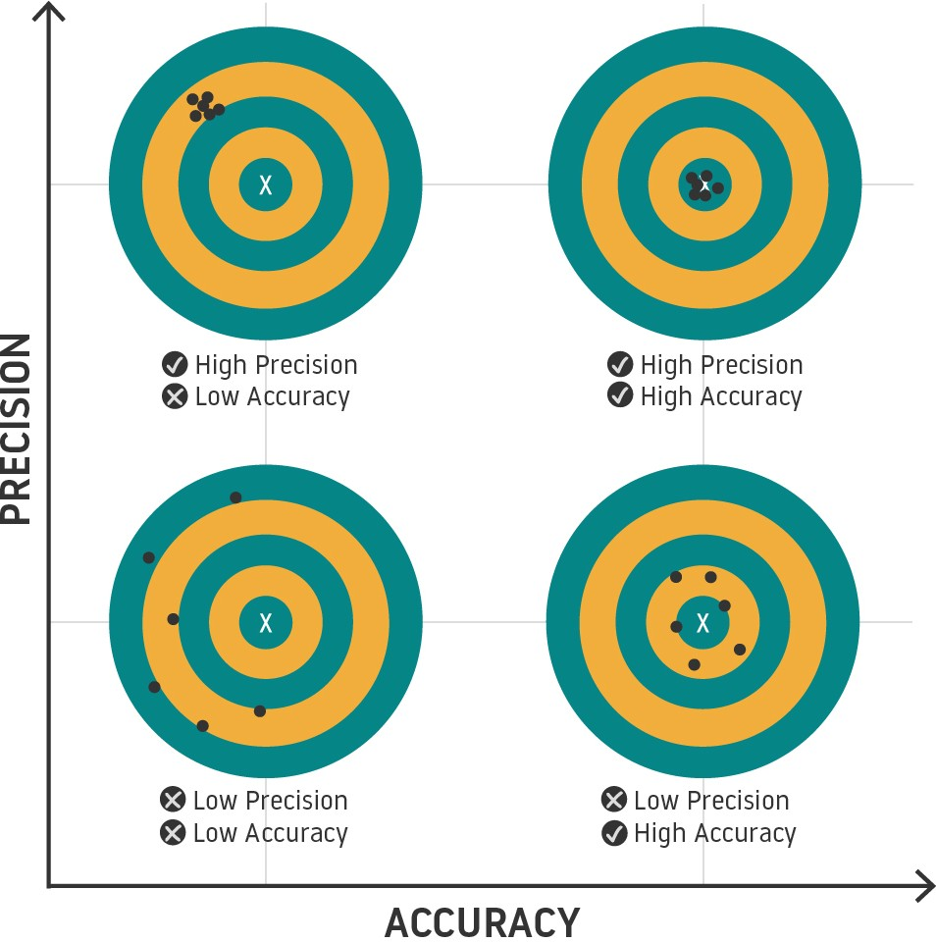

Figure : Effective and Accurate Prediction

#### To Reduce Anxiety

Patients can have a Virtual meet with the Doctor so that they can convey their symptoms and it will diagnose and assist them in more effective manner rather than creating stress due to traditional disease predictions.

Figure : Reduce Anxiety

### Objectives

#### Diagnose and analyze patients’ symptoms more effectively

This system will diagnose and analyze patients’ symptoms more effectively us­ing powerful Machine learning algorithms and classifiers and can recommend best available doctors to them.

#### Set reminders for their medicinal routine checkup

Patients can set reminders for their medicinal routine checkup and also for their regular appointments with their consulting Doctors.



Figure :consulting Doctors

#### ImplementLive Consultation

Patients can have a live chat or consultation as per their convenience with doctors for appropriate diagnosing the health problems which they are facing in order to treat them with proper care and prescription.

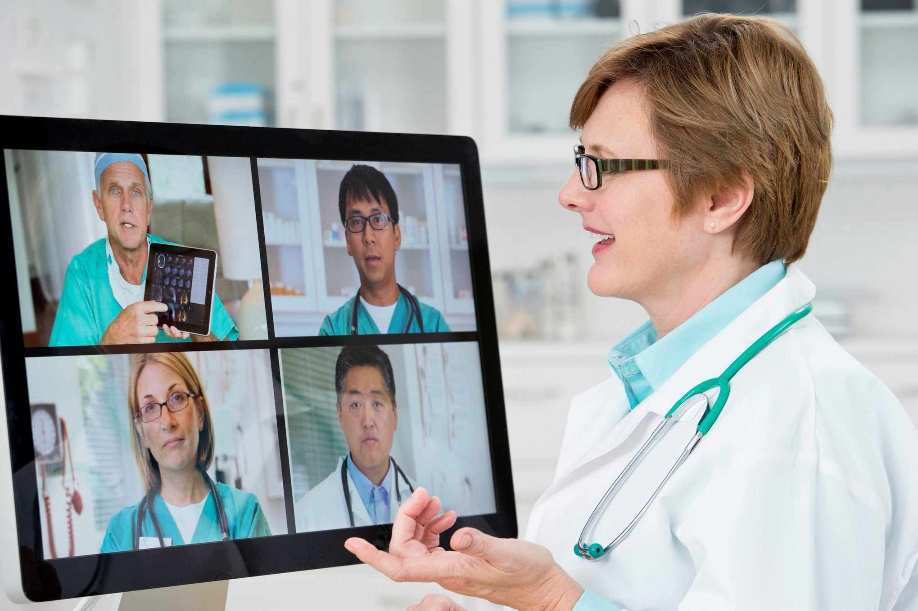

Figure :Live Consultation

# 1.5 Project Timeline



Figure: Time Plan for Implementation

# Chapter 2

# Literature Review

## 2.1 Designing Disease Prediction Model Using Machine Learn­ing Approach

People today suffer from a variety of illnesses as a result of their personal decisions and the environment. Predicting the disease early on becomes critical. However, the doctor believes that making an accurate prediction based on symptoms is too difficult.

The most difficult task is forecasting disease accurately. In order to solve this problem, data mining is critical. Each year, there is a significant increase in data in the medical sciences. As the amount of data in the medical and healthcare fields has grown, accurate medical data analysis has aided early patient treatment. Using disease data, a massive number of medical data is mined for hidden pattern information.

In this study, they proposed a broad illness prediction based on the patient's condition. To accurately forecast diseases, the K-Nearest Neighbor (KNN) and Convolutional Neural Network (CNN) machine learning algorithms were used. Disease prediction requires a data set of disease symptoms. Before making predictions, this model employs ensemble classification. This general disease prediction for an appropriate diagnosis takes into account the individual's lifestyle choices and knowledge about disease management. (Dahiwade, 2019)

Machine Learning Algorithms Used: KNN (K-Nearest Neighbors), CNN (Con­volutional neural network)

Accuracy: CNN – 84.50%, KNN – 81.12%

### 2.1.1 Advantages of Paper

* Precise and accurate.
* Algorithms are working efficiently with larger datasets.

### 2.1.2 Disadvantages of Paper

* Risks associated with disease are not displayed.
* Higher Memory Requirement.
* Less Efficiency and accuracy.
* Time required for classification is higher about 12900ms.

### 2.1.3 How to overcome the problems mentioned in Paper

* Prediction will be done at faster rate.
* Memory Requirement will be reduced.
* Risks associated with the diseases will be displayed.

## 2.2 Data Mining and Machine Learning for Symptom-Based Health Prediction

The total everyday health of an individual is essential for the body's efficient operation. Their research in this work focuses on developing a machine learning model to predict common diseases based on actual symptoms. Using a dataset of the most often exposed diseases, they created a relationship to predict potential diseases based on symptom input.

The suggested model combines word processing with the capacity of various machine learning algorithms to produce an accurate forecast. Tokenization was used in the word processor's implementation, and different methods were integrated to evaluate for similarity and effectiveness. It has various benefits for the healthcare sector, including early disease identification, quicker diagnosis, and medical history for inspection of patients, etc.

Training models, ML algorithms used: Scikit Learn Library and Python Pandas data frames to process data. Decision trees, random forest and naïve Bayesian algorithms. (Shetty, 2018)

Accuracy: Decision tree Algorithm - 98.18%, Random Forest Algorithm - 98.05%, Naive Bayes Algorithm – 98.55%.

### 2.2.1 Advantages of Paper

* Less Preprocessing.
* Strong independent Assumptions.
* Faster due to usage of conditional probability.

### 2.2.2 Disadvantages of Paper

* Less data set and number of parameters for classification.
* Decision trees are built on the entire dataset.
* Time required for training dataset is higher.
* It does not show all the components of the prediction system, but it focuses on the characteristic of the classification.

### 2.2.3 How to overcome the problems mentioned in Paper

* More parameters will be taken for accurate prediction.
* The time required to train the dataset will be reduced by preprocessing the dataset for faster results
* The selection of the best ML algorithm will take in order to improve the efficiency and accuracy of our project in terms of all requirements.
* The characteristics of the prediction system will be presented in detail for better analysis.

## 2.3 A new approach to predict diabetes using the naïve Bayesian classifier

One of the deadliest and most persistent conditions that can raise blood glucose levels is diabetes. The primary goal of this approach, as stated in this IEEE paper, is to examine the patient database for diabetics and predict the condition at an early stage.

The naive Bayes classification is applied to predict diabetes in this system. Information mining is the process of taking data from a data source and organizing it so that it can be used further. The information arrangement, which is a collection of data from diabetic patients, was made by gathering data from the clinic's warehouse, which has 1865 occurrences of different types. The findings indicate that the novel strategy is more accurate than conventional methods at predicting diabetes.

The output of this suggested system, which uses a naive Bayes classifier, will be a web interface that displays the presence or absence of diabetes based on inputs such as insulin level, age, and other factors. This improves the system's accuracy. (Priya, 2020)

Machine Learning Algorithms Used: Naive Bayes Accuracy: 96%

### 2.3.1 Advantages of Paper

* Simple and easy to predict.
* Performs well due to multiple class expectation.
* Accuracy is highest.

### 2.3.2 Disadvantages of Paper

* Assumes implicitly that all characteristics are mutually independent.
* The assumption of independent predictor features.

### 2.3.3 How to overcome the problems mentioned in Paper

* Prediction will be done faster and with less memory requirement and classifica­tion will be done more precisely with appropriate symptoms.
* Risk associated with the disease will be showcased after prediction.
* Selection of best ML Algorithms will be taken for development.
* Implementation of Live Consultation with Doctors for better treatment and diag­nosing of diseases.
* Reduce the limitations of less accurate Algorithms by implementing them in a sequenced manner.
* Specialized Doctor recommendation and nearest health centers from your loca­tion available for quick treatment.

## 2.4 Technical Review (Implementation Type)

I used Django Framework to build the operation of my web app and machine learning algorithms such as Naive Bayes, Linear Regression, K-Nearest Neighbor, Kernel SVM, and Decision Trees Algorithms for accurate disease prediction and analysis.

### 2.4.1 Benefits of technology

* Django is implemented in Python.
* Improved CDN connectivity and content management.
* Included battery frame.
* Fast processing.
* The Naive Bayes Algorithm is simple and straightforward to implement. It does not necessitate as much training data. It deals with both continuous and discrete data.

### 2.4.2 Reasons to use this technology

* Django allows for rapid development while also ensuring security.
* Django's architecture is Model-View-Template (MVT). Model View Template (MVT) is a software design template.
* It is made up of three essential parts: Model, View, and Model. These three layers are in charge of different things and can be used separately.
* The Naive Bayes algorithm scales well with the number of predictors and data points.
* It is quick and can make real-time predictions.
* It is not affected by irrelevant characteristics.
* If the assumption of feature independence is true, the Naive Bayes algorithm outperforms other models with less training data.
* When compared to numeric variables, the Naive Bayes algorithm performs exceptionally well with categorical input variables.

# Chapter 3

# System Analysis and Design

# 3.1 Project Management Approach

I managed my projects using agile techniques. Agile is a project management methodology that places a strong emphasis on ongoing product or service improvement through the use of short development cycles, or "sprints." I followed the following guidelines while working:

* Customer satisfaction will always come first, and this will be done by providing quick and consistent delivery.
* At each point in the process, adapting to changing conditions is done so to give the client a competitive edge.
* I made more frequent deliveries of a good or service.
* On a daily basis, our developers and stakeholders collaborate closely.
* Teams are given all the required resources, trust, and support to accomplish project goals, and all stakeholders and team members continue to be driven for the best project outcomes.
* Face-to-face meetings are thought to be the most effective and efficient method for the project's success.
* The gold standard of success is a finished product that functions.
* Agile approaches allow development teams and stakeholders to move at a steady and continuous pace, which is how sustainability is achieved.
* By maintaining an emphasis on technical quality and suitable design, agility is improved.
* Simpleness is crucial.
* Self-organizing teams have the greatest chance of producing the best architectures, designs, and fulfillment of requirements. Teams employ regular intervals to fine-tune habits and increase efficiency.

## 3.1.1 Roles and responsibilities

Table :Roles and responsibilities

|  |  |  |
| --- | --- | --- |
| Team members | Role | Responsibilities |
| System analyst | Requirement gathering  Make SRS | * Select appropriate requirements for the project. * Perform an analysis of the document. * Perform the analysis method you are going to perform and collect the data. * Create an SRS System Document |
| Designers | The design of a web application and its functions covering requirements. | * Design web pages according to user requirements. * Design Windows Forms according to user requirements. |
| Developers | Code the web application | * Create the system with no mistakes * Add fresh and cutting-edge features. * Strengthen the system's flaws. * Simplify the code. |
| Database developers | Develop the database for the system. | * Create a solid, precise database with the required tables and data columns. * Verify the database's functionality. |
| Testers | Web application testing | * Choose the best testing strategies. * For both applications, create a test strategy and test cases. * Based on the test results, provide a precise conclusion. * Interview people to get comments. * Make effective user interrogators to get user input. * Conduct quality control, locating any mistakes. |

## 3.1.2 Assumptions and Limitation

* Users of this Webapp can use this system.
* Users of this Webapp should have active internet.
* Users should provide appropriate symptoms for prediction.
* There will be a backup of the data after every cycle is completed.
* There will be a admin present 24/7 at the server.
* Highest accuracy is fetched with more than 2 or 3 symptoms.
* Have to work with the available resources.
* Need to manage the entire project within the one developer.

## 3.1.3 Feasibility Studies

### Operational Feasibility

QickDoc was maintained through the previous traditional system, a computerized system is proposed under the new project that I am presenting. Here, the employees of the company should be considered whether they are ready for it. However, as employees' time is well managed through this method, most people have a great preference for this method.

### Technical Feasibility

Before connecting this project to the organization, a technical feasibility study should be done to get an idea of ​​the technical capability of the organization. Essentially, the proposed system requires computers, servers, routers, etc. In addition, it is important to have other basic hardware such as music, keyboards, hard disks, processor and the software needed to build the system. The list of hardware and software required for this is given below.

Required Hardware

This system developed under Python, JS, CSS and HTML, it will be hosted locally and will require an internet connection for patients, so the minimum hardware requirements are:

* Windows 7 or later is required.
* Intel Core I3 Duo processor Processor RAM: 4GB or more
* Disk Space: 250GB or more
* Internet speed: at least 1Mbps

Required Software

Software

* OS - Windows 7 or greater
* Web browser – Chrome Web Browser
* Virus guard - Kaspersky

### Economic Feasibility

Economic feasibility is calculated based on the expected cost as well as the mandatory cost of building the system. For this, the economic structure must be calculated as follows:

Table :Economic Feasibility

|  |  |
| --- | --- |
| * Server (1 year hosting for the web application) * SSL Certificate * Site security essentials (protecting the site from hackers) * Site backup * Site backup | 45,000.00 |
| Web Domain (.LK) | 3,500.00 |
| Payment Gateway | 15,000. 00 |
| Internet connection (SLT Fiber) | 5,000. 00 |
| The cost of web application software | 50,000. 00 |
| Software Development | 120,000. 00 |
| Total Cost (LKR) | 238,500. 00 |

### Schedule Feasibility

The proposed time to complete this QickDoc is one month. I expect to complete all the work on the system within 2 months and hand it over to the authorities. Accordingly, the schedule feasibility of this project is highly valued based on the ability to complete the project and submit it to the organization within a month.

## 3.1.4 System Requirements Definition

System requirements definitions list the functions, attributes, and necessary and desired system features that the system must have. Consultations, interviews, and requirements workshops with customers and end users are some of the strategies used to get and collect data to define system specifications and requirement definitions. Both sorts of requirements are intended to be derived during the requirements definition phase:

### Functional requirements

They specify the fundamental capabilities that the system must offer and put the demands and objectives of the users as the end users first.

* whenever a user logs into the system, authentication must be performed.
* shutdown of the system in event of a cyberattack.
* System backup that is automatic.

#### Use case Diagram

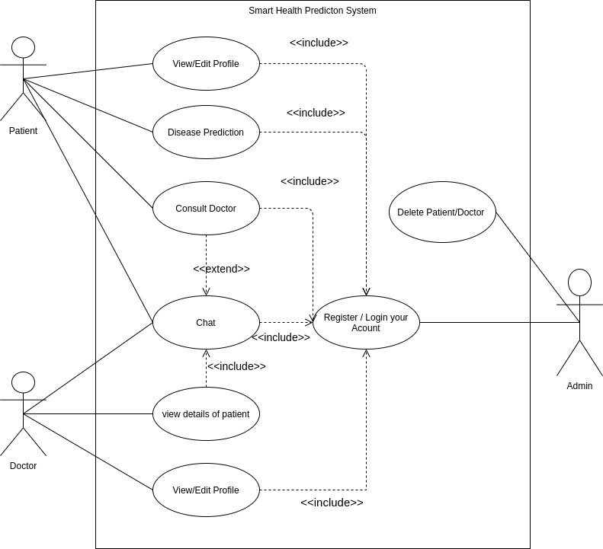

Figure :Use case Diagram For QuickDoc

### Data-flow Diagram

#### Level 0

DFD Level 0 for our systems focuses on the main output where patient gets the result of his/her disease analysis.

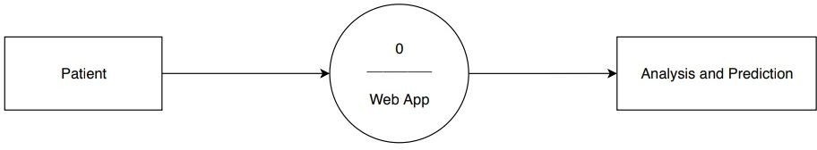

Figure :DFD Level 0 for QuickDoc

#### Level 1

DFD level 1 depicts that Patients symptoms will be saved in database as well as sent for classification and prediction accompanied by trained Machine Learning Model.

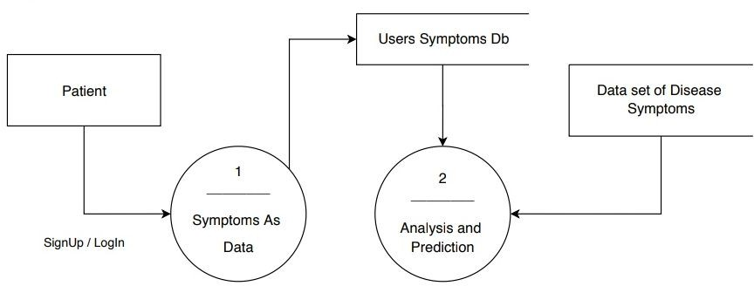

Figure :DFD Level 1 for QuickDoc

#### Level 2

DFD Level 2 the data will be analyzed and a complete prediction will be made. The predicted disease will be accompanied by some of it’s information as well as a doctor will be referred according to the classified disease. Patient can see the doctor’s ratings and can decide whether to go for live consultation or not.

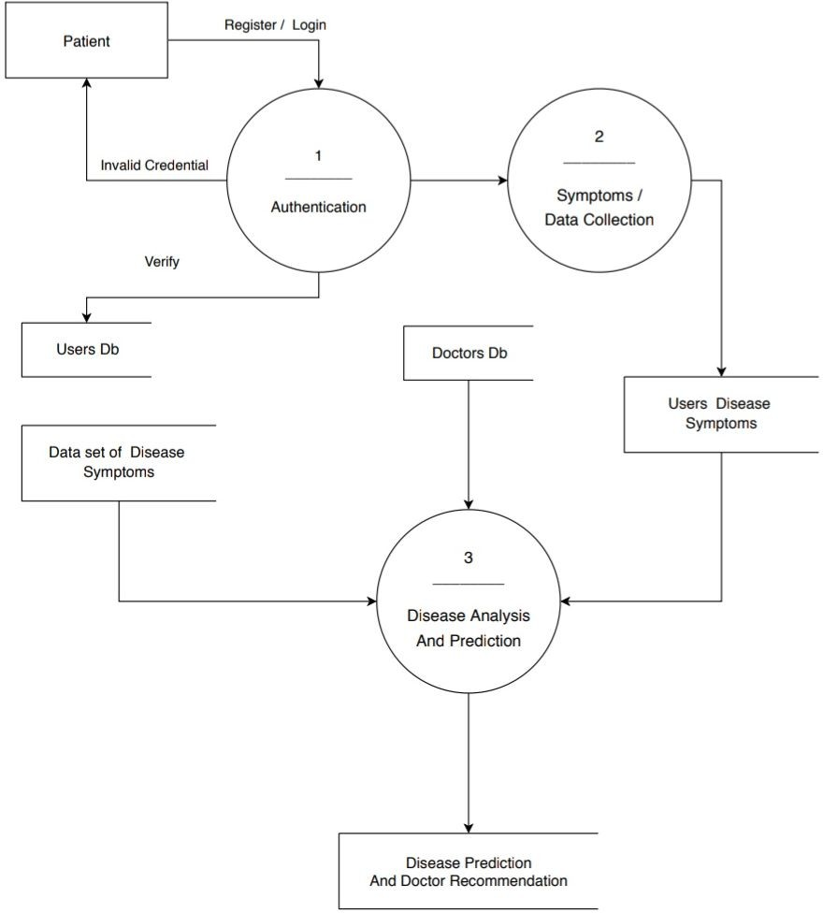

Figure :DFD Level 2 for QuickDoc

#### Activity Diagram

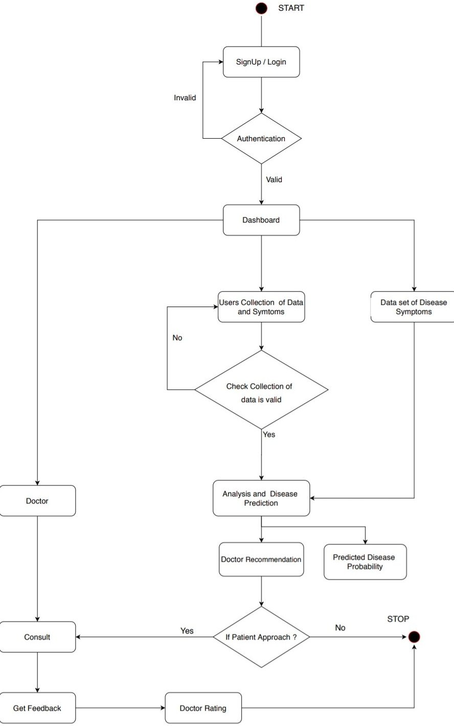

Figure : Activity Diagram for QuickDoc

**System prerequisites (non-functional requirements)**

* Emails should be issued no later than 12 hours following the action.
* Every request should be completed in ten seconds or less.
* If there are more than 10,000 visitors at the same time, the page should load in 3 seconds.

# 3.2 System Architecture Design

The conceptual model, or system architecture, defines the structure, behavior, and other elements of a system. An architecture description is a formal description and visualization of a system that is built up to assist analysis of its components and actions.

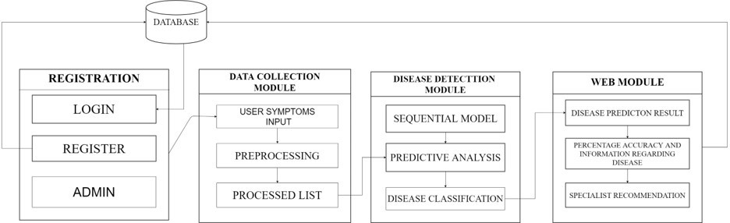

Figure :System Architecture Design Diagram for QuickDoc

## 3.2.1 Sub-system Development

This system consists of four modules Registration, Data Collection Module, Dis­ease Prediction Module and Web Module. In Registration module authentication must be done and in second module Data collection Module user symptoms input will be taken and based on that input symptoms Disease Prediction Module will analyze the disease probability and that will display through Web Module.

### Registration Module

Registration of patients and Doctors will be there through their personal portals and after that there will be a personal page for their purpose of patient and doctor.

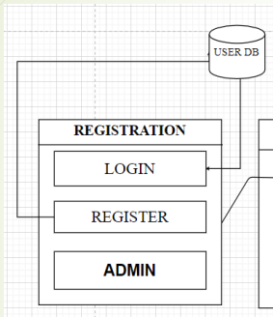

Figure :Registration Module

### Data Collection Module

In Data Collection Module there will be collection of symptoms of patient selected by the patient from our given symptoms list. This module is mainly concern with patient side.

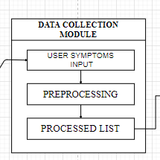

Figure :Data Collection Module

### Disease Prediction Module

In Data prediction Module there a prediction of disease will be done with the help of algorithms provided in back-end. The better probability of disease prediction result will be selected for further procedure.

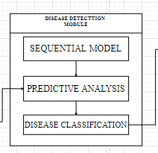

Figure :Disease Prediction Module

### Web Module

In web module there is contact between patient and doctor will be perform based on their disease predicted through previous module and they will contact with each other due this module in which we design a chat body system for them.

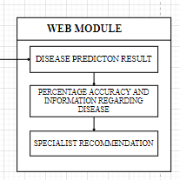

Figure :Web Module

# 3.3 Systems Integration

Assembling many subsystems or components into a single, larger system is the goal of system integration (SI), a phase or process in engineering. It makes certain that each integrated subsystem performs as needed. The use of SI to connect the functions of various systems results in additional functionalities that enhance the value of a system.

## 3.3.1 Component Diagram

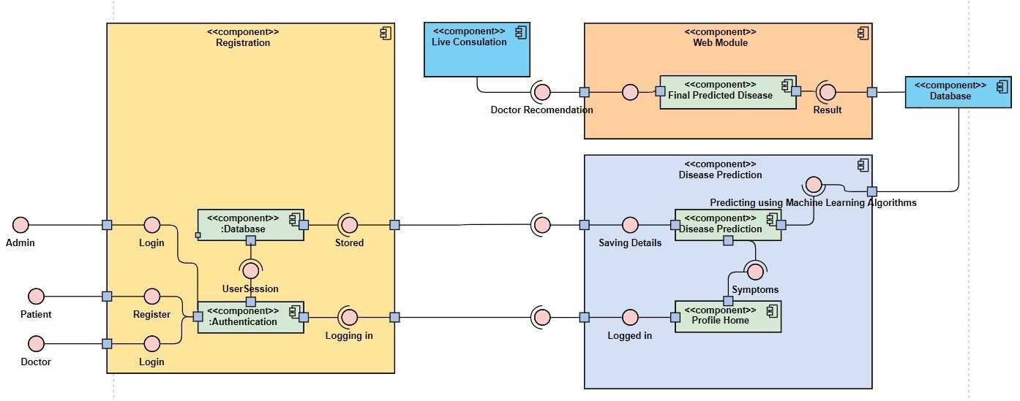

Figure :Component Diagram for QuickDoc

## 3.3.2 Class Diagram

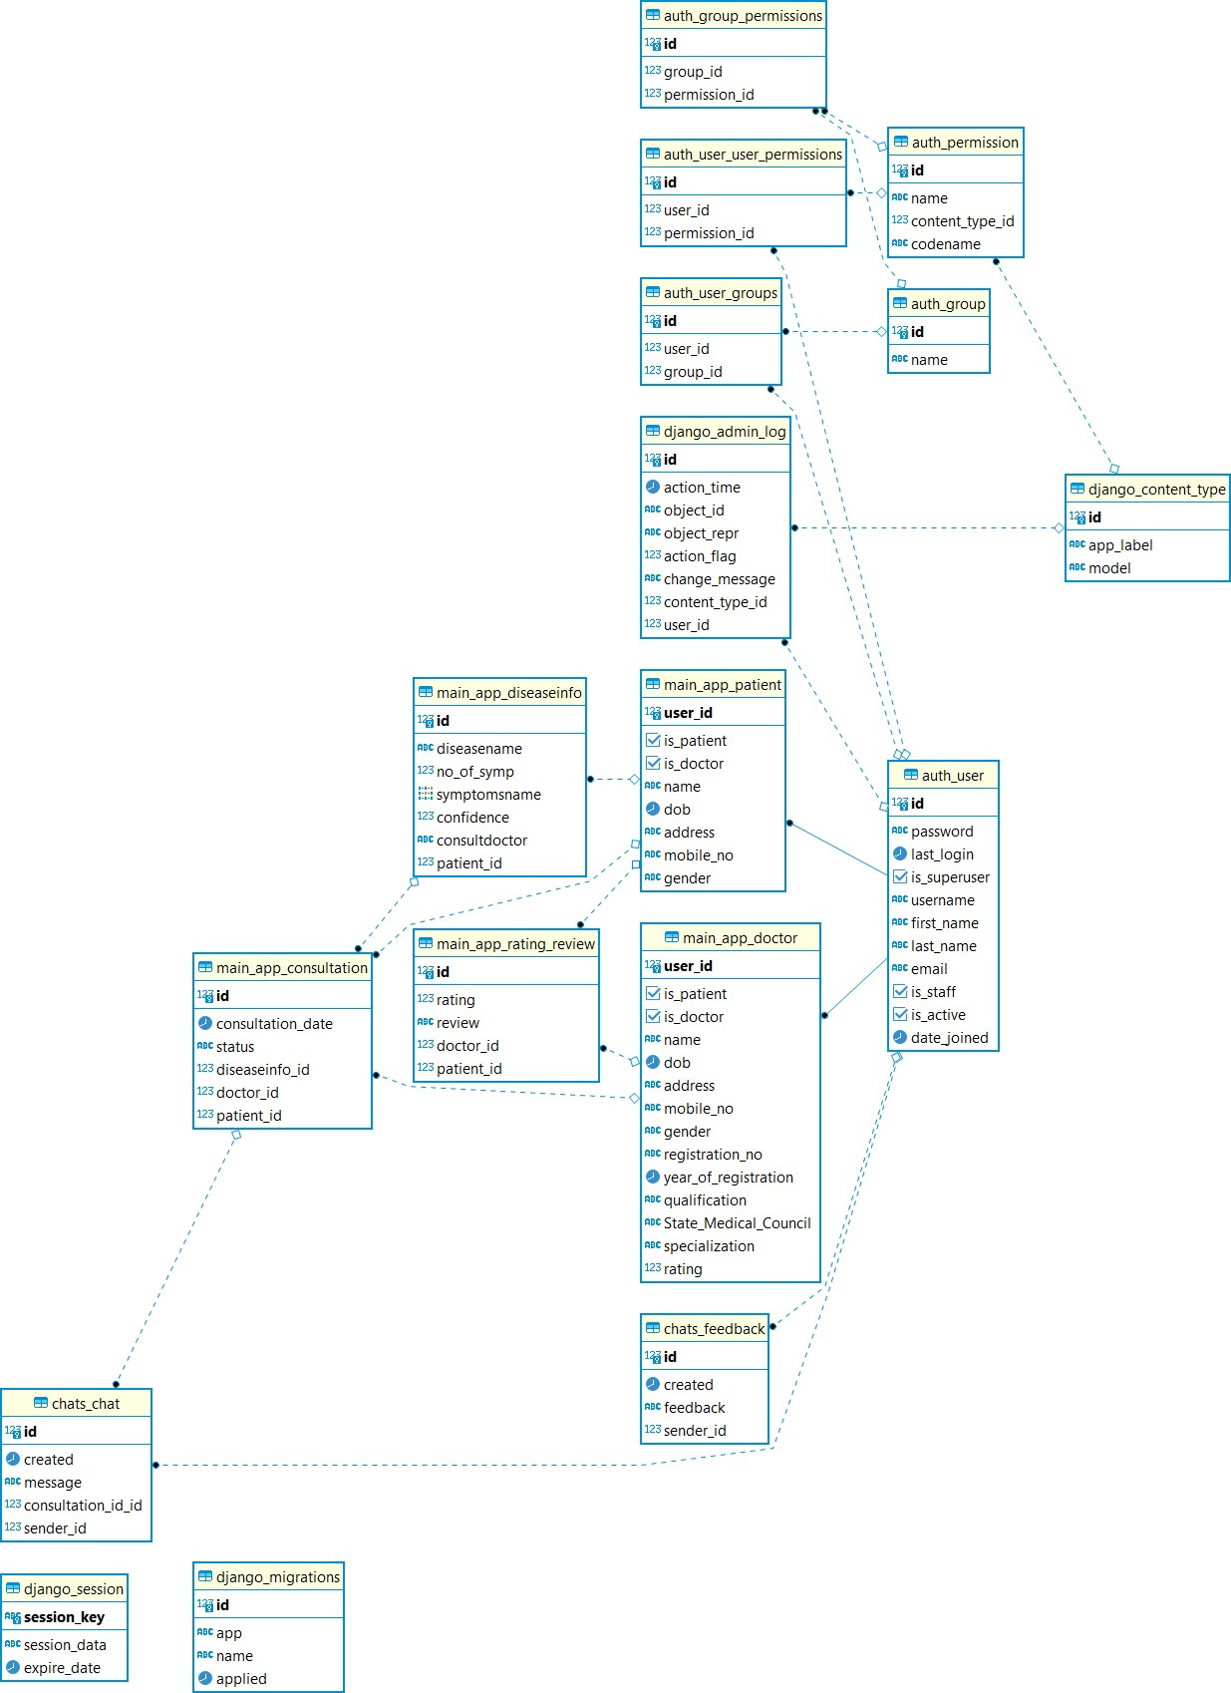

Figure :Class Diagram for Smart Health Disease Prediction System

## 3.3.3 Sequence Diagram

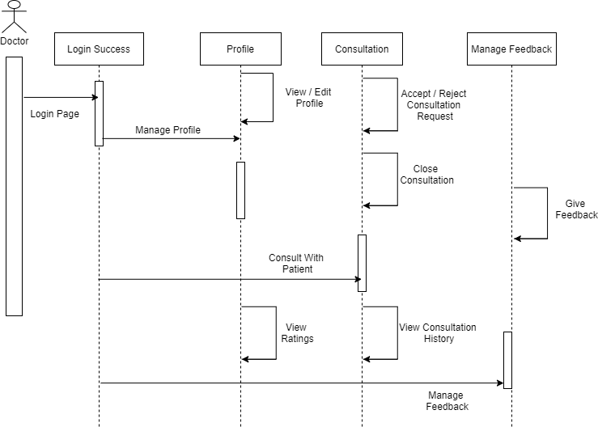

Figure :Sequence Diagram for Doctors

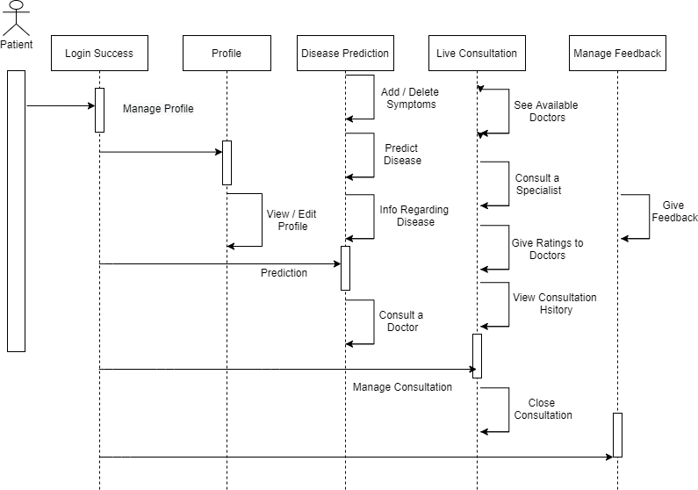

Figure :Sequence Diagram for Patients

## 3.3.4 Deployment Diagram

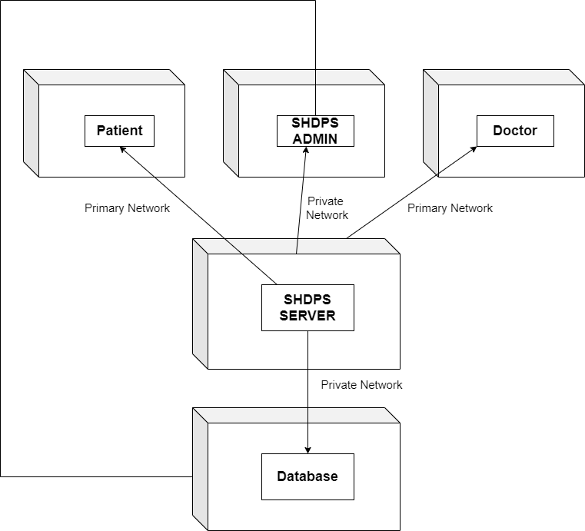

Figure :Deployment Diagram

# 3.4 Screenshots of User Interfaces

Important UI screenshots shown bellow

## 3.4.1 Home Page

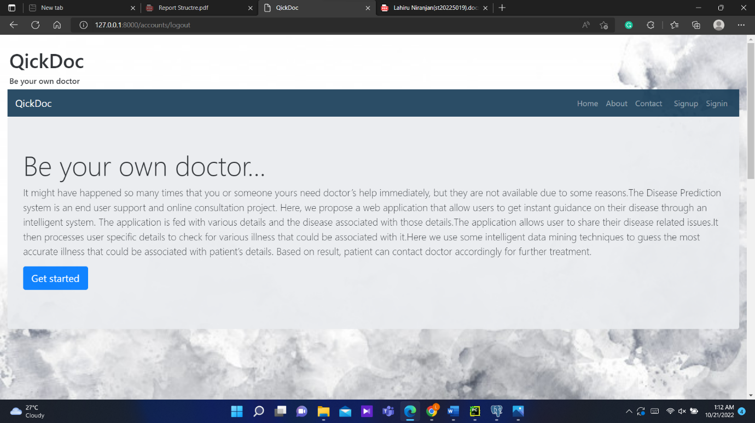

Figure :Home Page UI

## 3.4.2 Dashboards

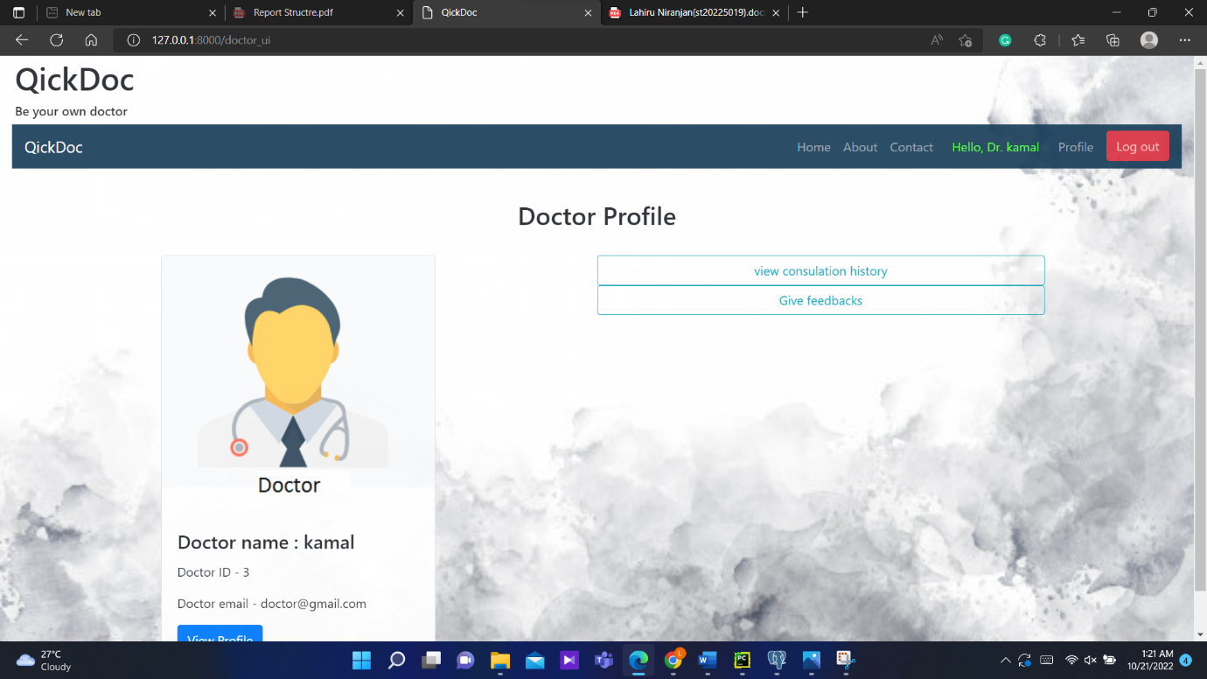

Figure :Doctor Dashboards UI

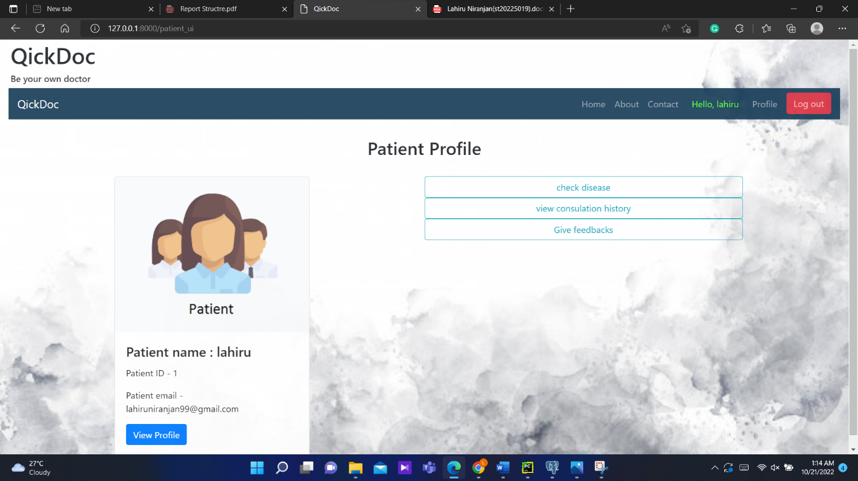

Figure :Patient Dashboards UI

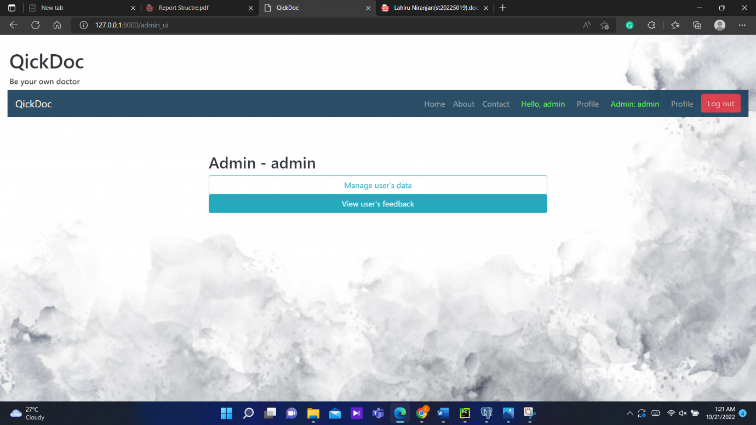

Figure :Admin Dashboards UI

## 3.4.3 Disease Prediction

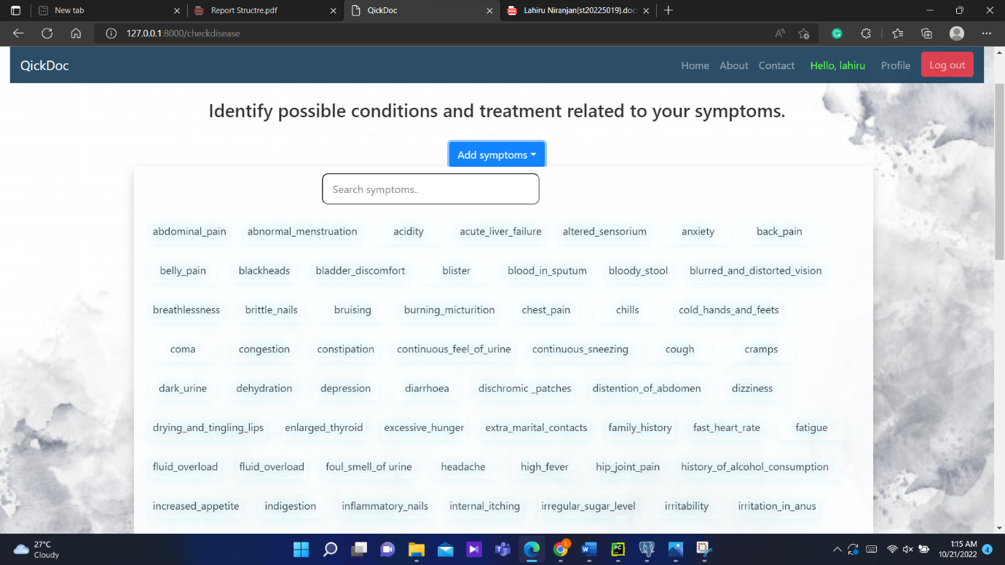

Figure : Disease Prediction UI

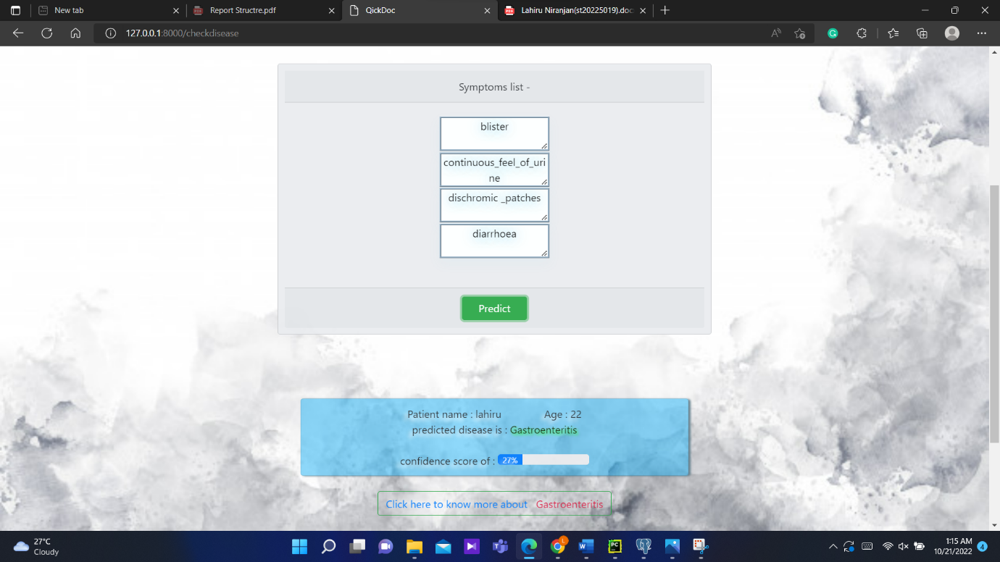

Figure :Disease Prediction UI

## 3.4.4 Consultation History

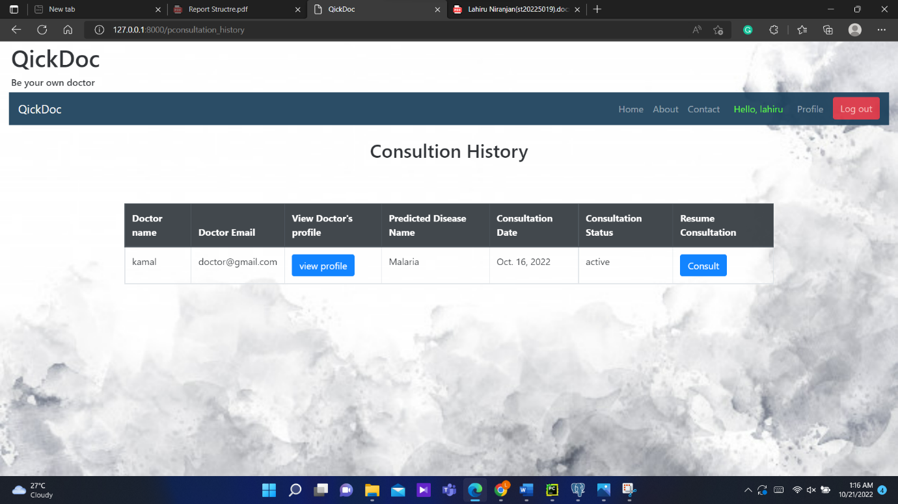

Figure :Consultation History

## 3.4.5 Live Consultation

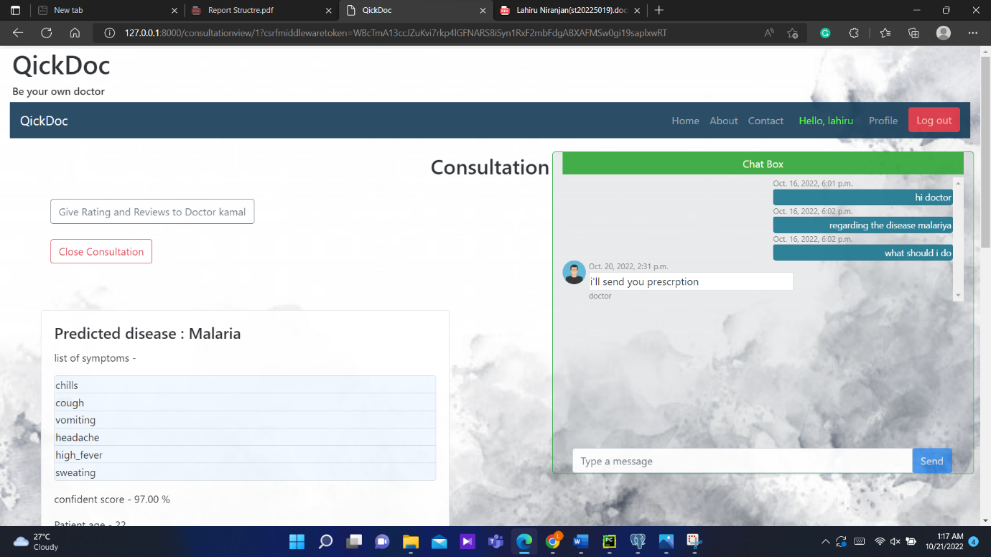

Figure :Live Consultation

# Chapter 4

# Data Analysis and Discussion

# 4.1 Product Perspective

By streamlining repetitive processes employed in the majority of today's online applications, such as routing, authentication, caching, and sessions, my disease prediction system web application aims to make the development process easier. An enhanced and fluid data process is intended to be provided by the vertically integrated web development environment.

## 4.1.2 Product Features

The following are the primary characteristics that this Smart Health Prediction System will have:

* Provides operating support for the majority of well-known and widely-used commercial operating systems.
* Users can create personal accounts for patients and doctors on the system, and the system offers features for updating and viewing profiles.
* The system is capable of supporting a huge number of online users at once, even though the figure is not specifically stated.
* provides patient users with a dashboard where they may see the outcomes of disease prediction based on the symptoms they supplied as input.
* Network of communication: There is a platform for patients and physicians to get in touch with one another and discuss health-related issues.

### User Classes and Characteristics

The two class of users called Patient and Doctor have them their different func­tionalities of the application, including:

* Patient Disease Prediction: Patient will be able to predict disease prediction in probability based entered symptoms without contacting doctors.
* Consult Page: Patient can consult with provided list of doctors after predicting disease result for further procedure.
* Doctors access: Doctors can view the details of patient about the disease and also the symptoms that mentioned while predicting through our portals so that doctors can study more while contacting with the patient.

### Operating Environment

* To enable the development of a web-based application that can be accessible from any web browser, the application is built using the Django framework.
* To store and retrieve data from a PostgreSQL database, the application will establish a connection with the backend.

### Design and Implementation Constraints

* The application needs to be used with the most recent JavaScript-capable web browser.
* The analytical data produced by the API may require a few seconds to load in the application.
* It is planned to use the extremely adaptable Django framework to build this system. The size of the data being shared or stored is taken into account when choosing which database to employ, and the right data management system will result in efficient performance.

# 4.2 System Features

### Accurate Prediction with faster results

Smart Health Disease Prediction System will predict accurate diseases based on the user’s symptoms with full-fledged efficiency and swiftness. QuickDoc will also show­case the consequences of that disease and the impact of that disease on other organs of the body. QuickDoc will work on the fastest Machine Learning Algorithm with the data set and it will predict the diseases with its powerful prediction capabilities.

### Live Consultation

QuickDoc will not only predict diseases but will also provide Live Consultation with the specialist for that disease in this amid pandemic. People are facing difficulties in consulting with the doctors as they are unable to have physical communication or contact with their doctors so this would be a beneficial interface for patients to consult with their doctors with these unique features.

### Patient’s Health Care

QuickDoc will provide regular follow-up appointments, reminders for routine checkups and also maintain the data records of patient’s previous health history. Some people have the habit of forgetting regular follow-ups with their doctors due to which the health is affected. So, to minimize this concern QuickDoc will continuously notify its users for consultations.

## 4.2.1 Resources required:

### Technologies used in the system

* Front-end technology: HTML, CSS, JavaScript, Bootstrap, jQuery
* Back-end technology: Django Framework, Python
* Database development tools: PostgreSQL

### Software Tools

* VScode
* PGAdmin4
* Anaconda Navigator

## 4.2.2 Non-functional Requirements

### Performance Requirements

* The user will see the dashboard page right away after logging in. The projected data, which is based on many symptoms and training data to forecast disease, will take 1-2 seconds to display.
* The application's disease prediction feature is adaptable and seamless so that the user's time is not wasted.
* To avoid redundant data and boost efficiency, the database should be standardized.

### Safety Requirements

* Sharding should be used in databases to make them redundant and prevent data loss.
* Information transmission to the server should be done securely and without changing the data.
* Database backups should be made on a regular basis and stored for a long time.

### Security Requirements

* The REST API's keys should be stored securely. The databases should only be accessible through the REST API.
* Databases ought to be protected by a firewall.
* A suitable login mechanism should be implemented for user accounts to prevent hacking.

# 4.3 Implementation

### 4.3.1 Approach

**Gathering the Data**: Preparing the data is the initial step in beginning any machine learning problem. I used a [Kaggle](https://www.kaggle.com/datasets/kaushil268/disease-prediction-using-machine-learning) dataset. This dataset is made up of two CSV files, one for training and one for testing. The dataset contains 133 columns in total, 132 of which are symptoms and the last column is the prognosis. (kaggle, 2022)

**Cleaning the Data**: Cleaning is the most important aspect of a machine learning project. The quality of our data determines the quality of our machine learning model. As a result, cleaning the data before providing it to the model for training is always essential. Because all of the columns in the dataset are numerical, the target column, prognosis, is translated to numeric data using a label encoder.

**Model Building**: After the data has been collected and cleaned, it can be utilized to train a machine learning model. Using this cleaned data, I trained the Support Vector Classifier, Logistic Regression, K-Nearest Neighbor, Naive Bayes Classifier, and Decision Tree. To evaluate the models' quality, a confusion matrix will be employed.

**Inference**: After training, the five models used the results of all five models to predict the disease for the input symptoms. This strengthens and improves the accuracy of my overall prediction. (geeksforgeeks, 2022)

### 4.3.2 Disease Prediction

This project, SMART HEALTH DISEASE PREDICTION SYSTEM, is entirely focused on disease prediction. Because health is a vital aspect with which no one is ready to take any risks, the major objective is to give powerful analysis features with the highest level of accuracy in forecasting diseases. As everyone is aware, a person's health is their most valuable possession. Therefore, it would be more advantageous and helpful in the analysis for the treatment of that condition to maintain a healthy lifestyle by anticipating or forecasting diseases and their impact on other organs at an early stage. With the aid of machine learning, I created a Smart Health Disease Predictor to solve this real-world issue.

The Smart Health Disease Prediction System will accurately and quickly predict diseases based on the user's symptoms. Additionally, QuickDoc will highlight the effects of the illness and how they affect other bodily organs. QuickDoc will use the data set and the quickest machine learning algorithm to predict the diseases using its strong prediction capabilities.

Accuracy is the project's precise aim. Since my system deals with health-related issues, which can occasionally be serious if it is inaccurate, I will attempt to make it as accurate as possible in comparison to the systems that have already been suggested. We will work to make our system more user-specific so that both patients and medical professionals can profit from it. Our system won't just be limited to prediction.



Figure :Symptoms Addition Module

### 4.3.3 Machine Learning Module

On the basis of the end user's symptoms and the system's confidence score, I have leveraged the vast capacity of machine learning algorithms in my system to forecast diseases for the user. I have put five machine learning algorithms into practice and trained them so that we can use them going forward. The following are the implemented algorithms: -

* Decision Tree
* K - Nearest Neighbors
* Kernel Support Vector Machine
* Naive Bayes
* Logistic Regression

#### Logistic Regression

Logistic regression is a well-known Machine Learning technique that is part of the Supervised Learning method. A set of independent variables is used to predict the category dependent variable. Logistic regression predicts the output of a categorical dependent variable.

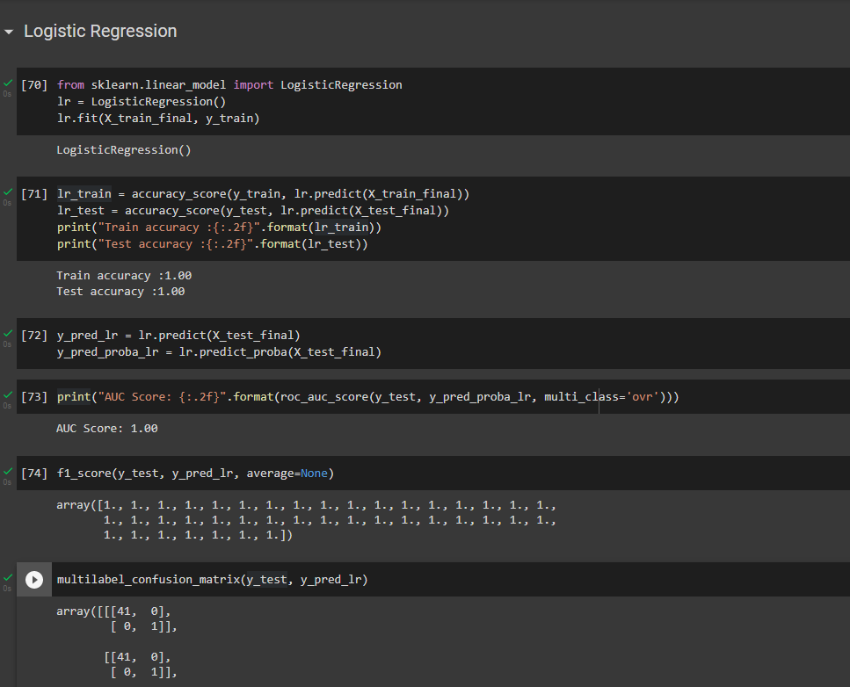

Figure :Logistic Regression

#### K - Nearest Neighbor

K-Nearest Neighbor is a simple machine learning technique based on the supervised learning method. The K-NN algorithm assumes that the new and existing cases are comparable, and it assigns the new instance to the category that is most similar to the existing categories. Although the K-NN method is most commonly used for classification problems, it can also be used for regression. Because K-NN is a non-parametric approach, no assumptions about the underlying data are made.

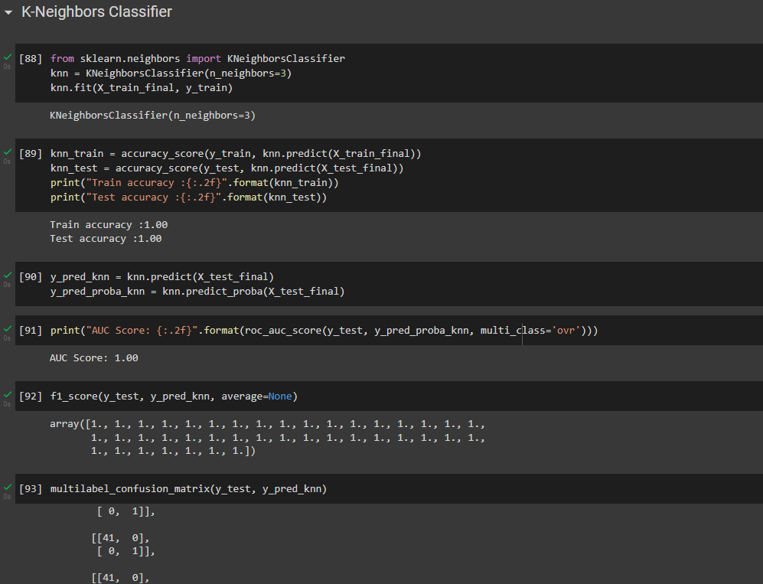

Figure :K - Nearest Neighbor

#### Kernel - Support Vector Machine

SVM techniques employ a set of mathematical operations known as the kernel. The kernel receives data and turns it into the desired form. Different SVM algorithms employ different kernel functions. These functionalities come in a variety of flavors. Linear, nonlinear, polynomial, sigmoid, and radial basis functions are examples (RBF). Explain how to use the kernel functions for vectors, text, images, graphs, and sequence data. RBFs are the most common type of kernel function. because it responds locally and predictably along the entire x-axis.

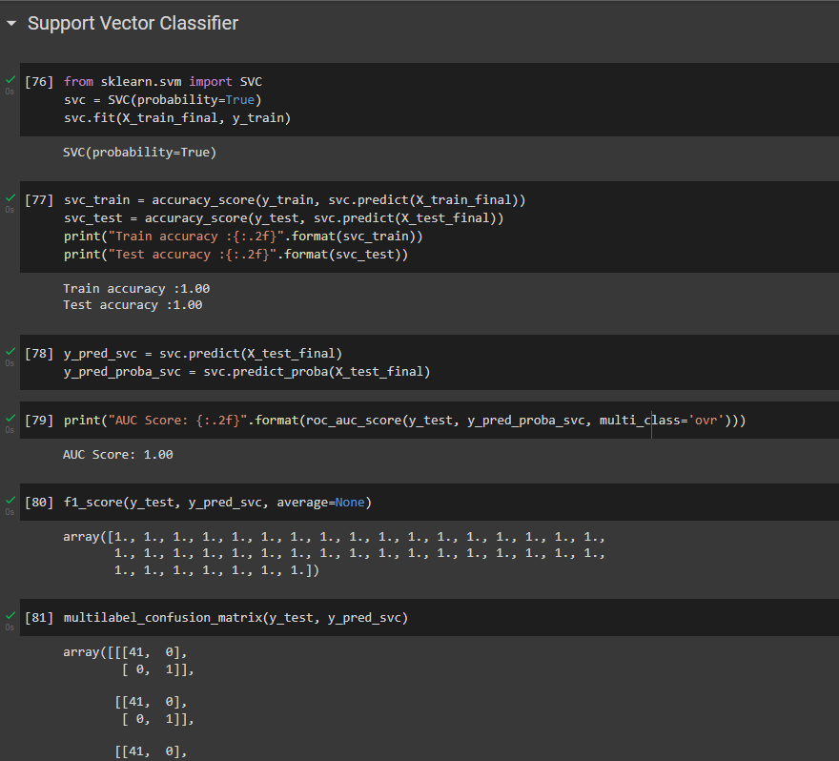

Figure :Kernel - Support Vector Machine

#### Naïve Bayes

Naive Bayes classifiers are a type of classification method based on the Bayes' Theorem. It is more of a family of algorithms than a single approach, and they are all founded on the premise that each pair of features being classified is independent of the other. There are three types of Nave Bayes models: Gaussian, Multinomial, and Bernoulli Naive. Multinomial and Gaussian distributions Our prediction system employs two types of naive bayes.

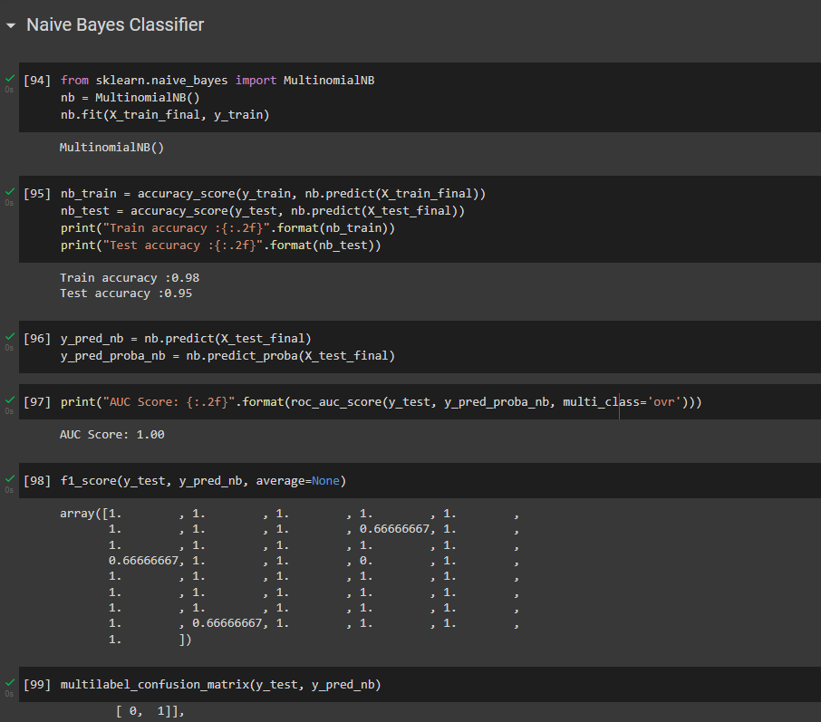

Figure :Naïve Bayes

#### Decision Tree

A decision tree, a supervised learning method, can be used to address classification and regression issues, but it is often preferred for doing so. It is a tree-structured classifier, with internal nodes representing dataset features, branches representing the decision-making process, and each leaf node representing the classification result. A decision tree's two nodes are the Decision Node and the Leaf Node. While Leaf nodes are the outcomes of decisions and have no further branches, Decision nodes are used to make decisions and contain many branches. Based on predefined conditions, it is a graphical representation of all alternative solutions to a choice or problem. It is called a decision tree because, like a tree, it starts with the root node and evolves by adding more branches to form a tree-like structure.

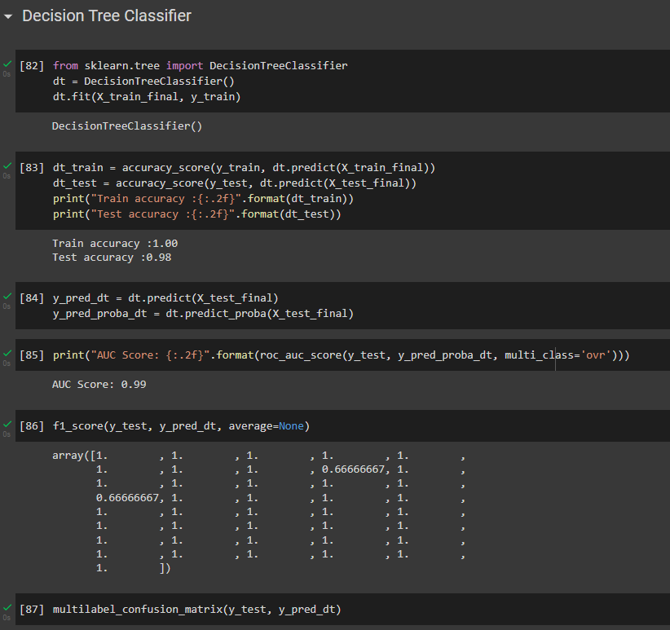

Figure :Decision Tree

### 4.3.4 Comparing the test accuracy of different classifier models

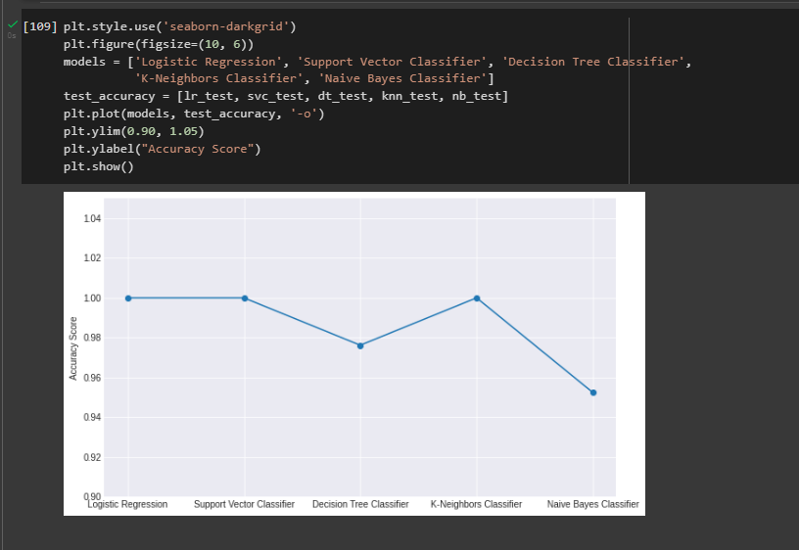

Figure :Comparing the test accuracy of different classifier models

### 4.3.5 Live Consultation Module

Our system is designed to help patient in such tough times where whole world is suffering from pandemic a lockdown is imposed on different parts of the world. Our system aims to bring the Doctors and patients much closer while everyone is at their homes by connecting them virtually through our platform and patient can seek medical help through our website by making direct one to one live consultation with the doctors available / registered on our platform.

Our system will not only bridge the gap between doctors and patients but will also try to make the process more and more simplified. Not only that but the poor one’s who cannot afford to consult doctors directly can also seek help through our plat­form since doctors who wants to do social service are most welcome on our platform and it doesn’t even need much efforts from both sides since every process in online and can be done on the go.

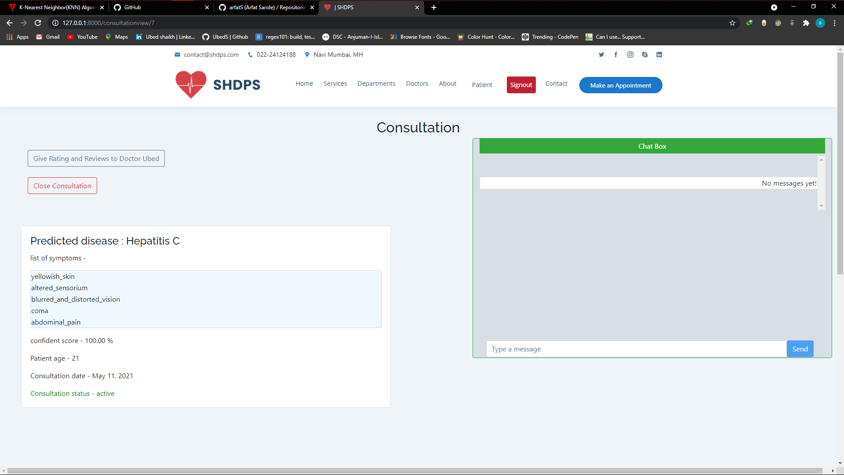

Figure :Live Consultation Module

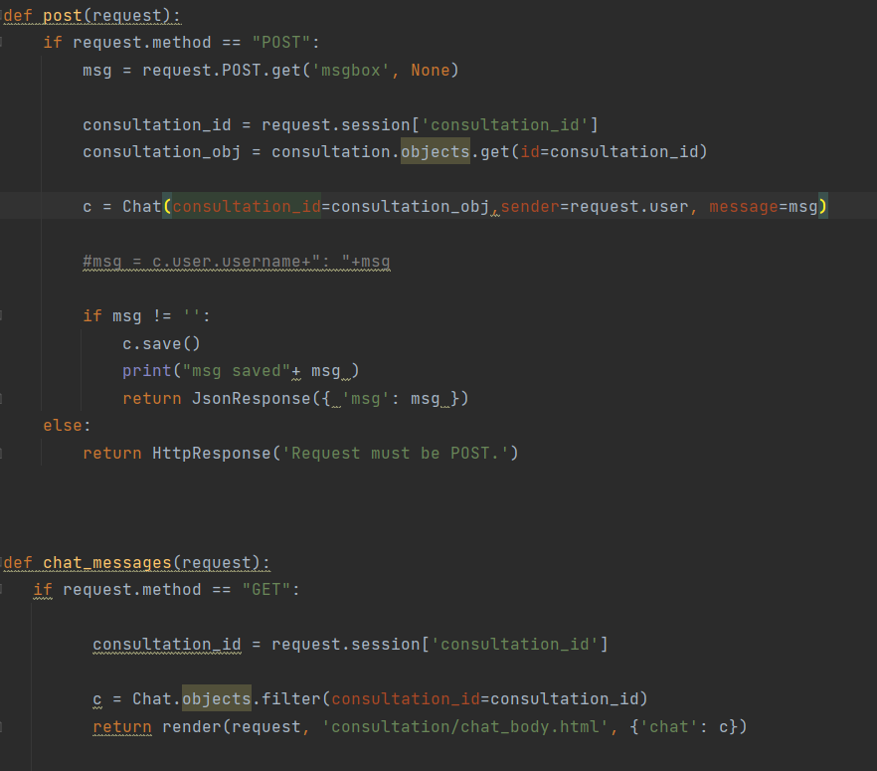

Figure :Live Consultation Module

# Chapter 5

# Evaluation and Testing

## 5.1 Testing

### 5.1.1 Black Box Testing

Black box testing is a technique for testing software applications' functionality without having access to their underlying code structure, implementation details, or internal methods. The major source of black box testing is the customer's statement of requirements. Black Box Testing is completely focused on software requirements and standards, and it primarily focuses on software entry and output. Also known as a behavioral test. A black box system is similar to a search engine. The results display when you type text into the search box and press Enter. In this instance, the method used to generate your search result is concealed from you. (Hamilton, 2022)

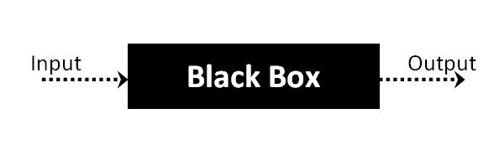

Figure :Black Box Testing

### 5.1.2 White Box Testing

White-box tests are a type of test that analyzes the program's architecture and generates test data from the program's logic and code. During the white box test, testers can see the code. Clear Box Testing, Open Box Testing, Transparent Box Testing, Code-based Testing, and Glass Box Testing are other names for it. The primary goal of this test is to locate and correct hidden mistake problems in the system.

(Hamilton, 2022)

### 5.1.3 Unit Testing

Unit testing is a type of testing in which the developer directly examines individual modules to detect issues. The functionality of standalone modules is as follows. Unit tests are used to ensure the correctness of the isolated code. A unit is the smallest testable component of any software system. It always has one or more inputs and, more often than not, an output. A unit component is a particular application function or line of code. Unit tests are typically performed by developers utilizing the white box testing technique.

(javatpoint, 2021)

## 5.2 Test Plan

One of the most critical jobs is to ensure that the baseline plan includes a task list and milestones to track project progress. A test plan is a written description of the system testing scope and processes. It serves as the foundation for formally testing in a project. The purpose of test planning is to record the test strategy, as well as to establish the scope and risks to be tested..

Table :Test Plan

|  |  |  |  |
| --- | --- | --- | --- |
| **Test Case Number** | **Test Case Name** | **Steps** | **Excepted result** |
| TC1 | Patient |  |  |
| TC1.1 | To check registration and login success as patient | Enter  Username = Adam  Password = Adam | User created and Login to the patient account successfully |
| TC1.2 | To verify that the patient login failed | Enter  Username = Adam  Password = 1234 | Log in to patient account Unsuccessful "Invalid credentials" |
| TC1.3 | To check patient Profile and Update Data | Enter Address = Nugegoda | Display “New data is saved” |
| TC1.4 | To check Dieses Prediction | Add Symptoms: “acidity, chest_pain, diarrhea, Dark_urine” | Display predicted dieses and confidence score |
| TC1.5 | To check selecting a Doctor and Live consultations | Select a Doctor and send text massages | Selected a Doctor and sent text massages successfully |
| TC1.6 | To check giving feedback and giving ratings to a doctor | Add feedback message and rating to a doctor | feedback message and rating to a doctor detail added successfully to the system |
| TC2 | Doctor |  |  |
| TC2.1 | To check registration and login success as doctor | Enter  Username = Jane  Password = Jane | User created and Login to the patient account successfully |
| TC2.2 | To check Login Unsuccess as doctor | Enter  Username = jane  Password = 1234 | Login to the doctor account Unsuccessfully “Invalid Credentials” |
| TC2.3 | To check Doctor Profile and Update Data | Enter  name = kamal | Display “New data is saved” |
| TC2.4 | To check selecting a patient and Live consultations | Select a patient and send text massages | Selected a Patient and sent text massages successfully |
| TC3 | Admin |  |  |
| T3.1 | To check login success as admin | Enter  Username = admin  Password = admin | User Login to the admin account successfully |
| TC3.2 | To check manage users by admin |  | Manage users by admin account successfully |
| TC3.3 | To check manage data by admin |  | Manage data by admin account successfully |

## 5.3 Test Cases

Table :TC1.1

|  |  |
| --- | --- |
| **Test Case** | TC1.1 |
| **Objectives** | To verify successful enrollment and login as a patient |
| **Test Data** | Username = Adam  Password = Adam |
| **Expected Result** | User created and Login to the patient account successfully |
| **Actual Result** |  |
| **Test Result** | Success |
| **Test Conclusion** | Actual outcome = Expected outcome |

Table :TC1.2

|  |  |
| --- | --- |
| **Test Case** | TC1.2 |
| **Objectives** | To check for failed login as a patient |
| **Test Data** | Username = Adam  Password = 1234 |
| **Expected Result** | Failed to login to patient account "Invalid credentials" |
| **Actual Result** |  |
| **Test Result** | Success |
| **Test Conclusion** | Actual outcome = Expected outcome |

Table :TC1.3

|  |  |  |
| --- | --- | --- |
| **Test Case** | | TC1.3 |
| **Objectives** | | To review patient profiles and update data |
| **Test Data** | | Address = Nugegoda |
| **Expected Result** | | "New data saved" |
| **Actual Result** |  | |
| **Test Result** | | Success |
| **Test Conclusion** | | Actual outcome = Expected outcome |

Table :TC1.4

|  |  |
| --- | --- |
| **Test Case** | TC1.4 |
| **Objectives** | To check Dieses Prediction |
| **Test Data** | Symptoms: “acidity, chest_pain, diarrhea, Dark_urine” |
| **Expected Result** | Display predicted dieses and confidence score. |
| **Actual Result** |  |
| **Test Result** | Success |
| **Test Conclusion** | Actual outcome = Expected outcome |

Table :TC1.5

|  |  |
| --- | --- |
| **Test Case** | TC1.5 |
| **Objectives** | Check your doctor's choice and live consultations |
| **Test Data** | Choose a doctor and send a text massage |
| **Expected Result** | Chose a doctor and successfully sent text massages |
| **Actual Result** |  |
| **Test Result** | Success |
| **Test Conclusion** | Actual outcome = Expected outcome |

Table :TC1.6

|  |  |
| --- | --- |
| **Test Case** | TC1.6 |
| **Objectives** | Check the provision of feedback and ratings to the doctor |
| **Test Data** | Add feedback message and rating to a doctor |
| **Expected Result** | feedback message and rating to a doctor details added successfully to the system |
| **Actual Result** |  |
| **Test Result** | Success |
| **Test Conclusion** | Actual outcome = Expected outcome |

Table :TC2.1

|  |  |
| --- | --- |
| **Test Case** | TC2.1 |
| **Objectives** | Verify that you have successfully registered and logged in as a doctor |
| **Test Data** | Username = Jane  Password = Jane |
| **Expected Result** | User created and Login to the patient account successfully |
| **Actual Result** |  |
| **Test Result** | Success |
| **Test Conclusion** | Actual outcome = Expected outcome |

Table :TC2.2

|  |  |
| --- | --- |
| **Test Case** | TC2.2 |
| **Objectives** | To verify that login fails as a doctor |
| **Test Data** | Username = jane  Password = 1234 |
| **Expected Result** | Login to the doctor account Unsuccessfully “Invalid Credentials” |
| **Actual Result** |  |
| **Test Result** | Success |
| **Test Conclusion** | Actual outcome = Expected outcome |

Table :TC2.3

|  |  |  |
| --- | --- | --- |
| **Test Case** | | TC2.3 |
| **Objectives** | | To check Doctor Profile and Update Data |
| **Test Data** | | name = kamal |
| **Expected Result** | | Display “New data is saved” |
| **Actual Result** |  | |
| **Test Result** | | Success |
| **Test Conclusion** | | Actual outcome = Expected outcome |

Table :TC2.4

|  |  |  |
| --- | --- | --- |
| **Test Case** | | TC2.4 |
| **Objectives** | | To check selecting a patient and Live consultations |
| **Test Data** | | Select a patient and send text massages |
| **Expected Result** | | Selected a Patient and sent text massages successfully |
| **Actual Result** |  | |
| **Test Result** | | Success |
| **Test Conclusion** | | Actual outcome = Expected outcome |

Table :TC3.1

|  |  |  |
| --- | --- | --- |
| **Test Case** | | TC3.1 |
| **Objectives** | | To verify a successful login as an administrator |
| **Test Data** | | Username = admin  Password = admin |
| **Expected Result** | | Successfully logged in to the user administrator account |
| **Actual Result** |  | |
| **Test Result** | | Success |
| **Test Conclusion** | | Actual outcome = Expected outcome |

Table :TC3.2

|  |  |  |
| --- | --- | --- |
| **Test Case** | | TC3.2 |
| **Objectives** | | To check manage users by admin |
| **Test Data** | |  |
| **Expected Result** | | Manage users by admin account successfully |
| **Actual Result** |  | |
| **Test Result** | | Success |
| **Test Conclusion** | | Actual outcome = Expected outcome |

|  |  |  |
| --- | --- | --- |
| **Test Case** | | TC3.3 |
| **Objectives** | | To check manage data by admin |
| **Test Data** | |  |
| **Expected Result** | | Manage data by admin account successfully |
| **Actual Result** |  | |
| **Test Result** | | Success |
| **Test Conclusion** | | Actual outcome = Expected outcome |

# Chapter 6

# Conclusion and Future Work

## 6.1 Conclusion

As the continuing pandemic and fuel crisis has demonstrated, health and lives are truly valuable and important. A healthy life is the greatest wealth. My guiding principle during the development of this project was to assist the general public by addressing their health-related issues.

I created this web application to analyze and predict diseases using several machine learning algorithms based on user-provided symptoms, and it has shown to be quite effective by offering the highest accuracy and precise prediction. In order to let my users to receive proper medical treatment from home during an ongoing pandemic, I also made live doctor consultations available to them.

This project is a carefully thought-out combo for generic healthcare, offering the finest possible options for both evaluating and predicting diseases. receiving information on the dangers that a disease prediction poses to other body organs as well. For communicating and obtaining treatment as quickly as feasible, this research also suggested using a specialist doctor.

With this project, I put in a tremendous amount of work to develop solutions for people's everyday health issues. In the future, 1 hope to create more projects to aid those in need and improve society as a whole.

## 6.2 Future Scope

I intend to continue working on my concept in order to make it a marketable and leading product. Some of the additions that I believe are required for it to happen are as follows:

* Making it cloud-deployable for worldwide accessibility.
* Increasing the dataset by predicting more diseases using our Disease Addition Program.
* Creating a more user-friendly user interface.
* Adding more Real Time Health Care functions such as BP, Sugar Level, Body Temperature, RBC WBC Readings, and so on.
* Using **data scraping**, customize this project with live Health Blogs.

# Appendices

**Appendices 01**

Data Set: 

**Appendices 02**

Architecture of the System

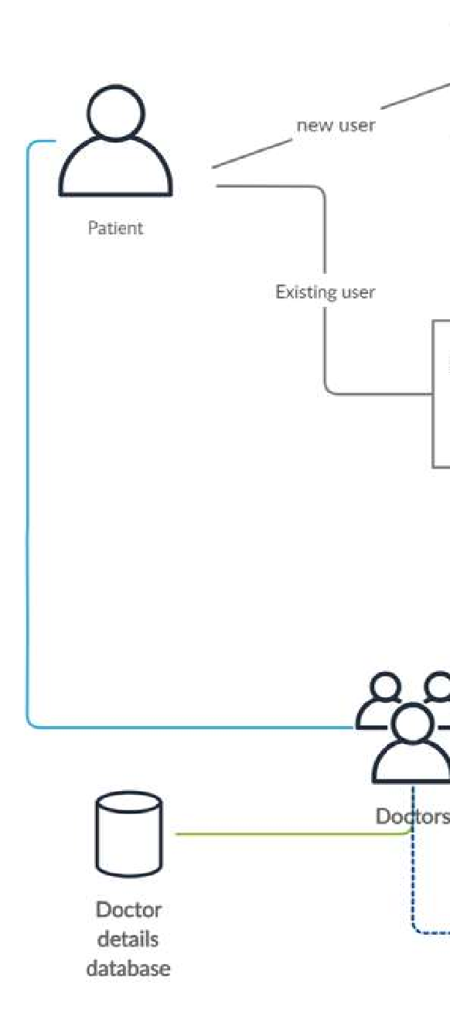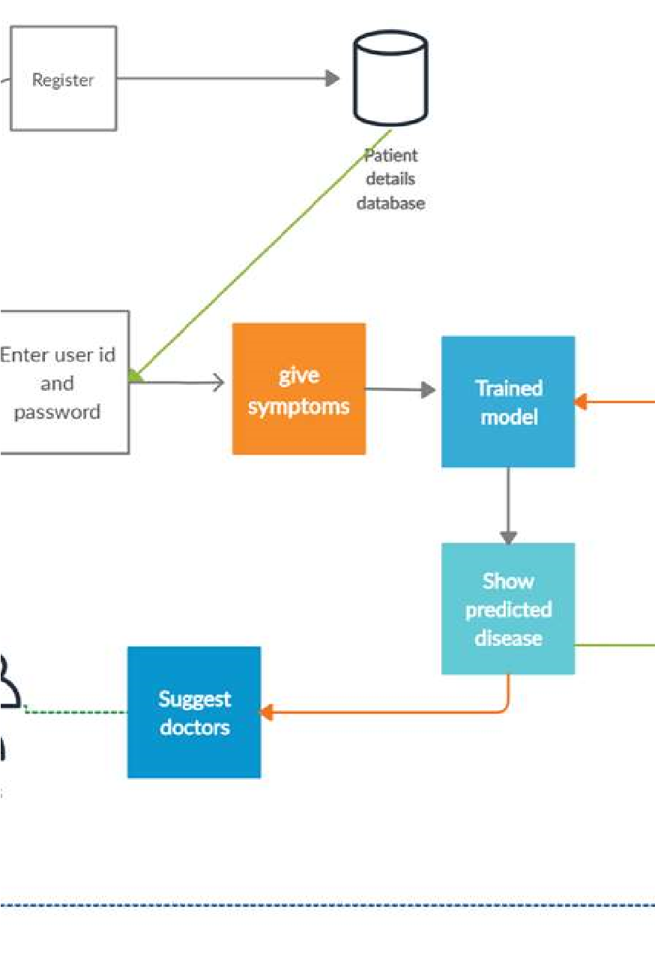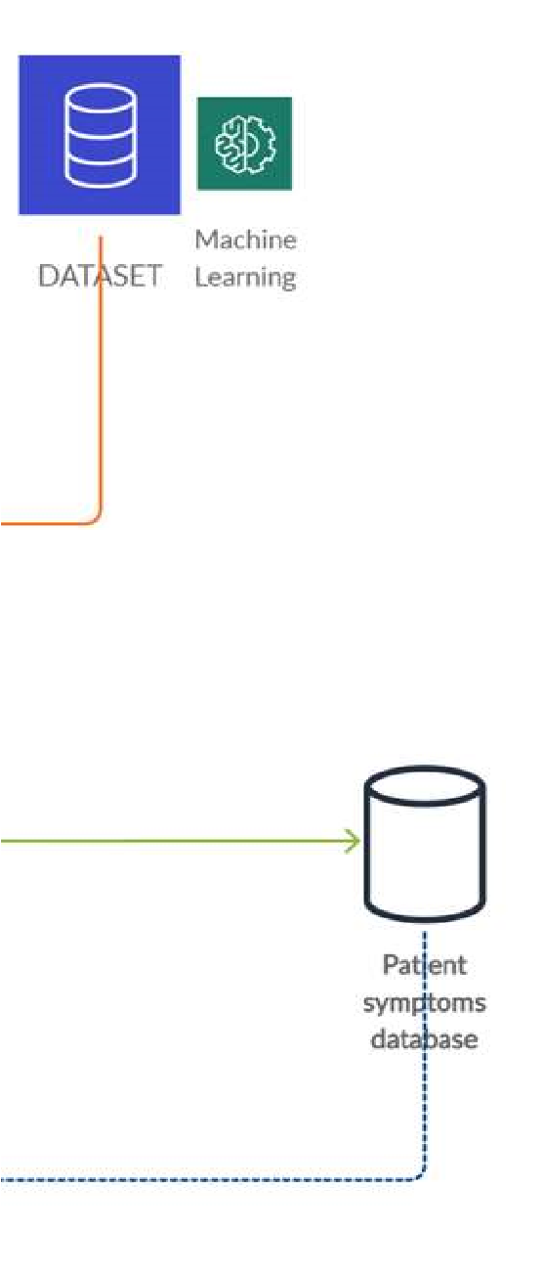

**Appendices 02**

Database QuickDoc-

Users table-

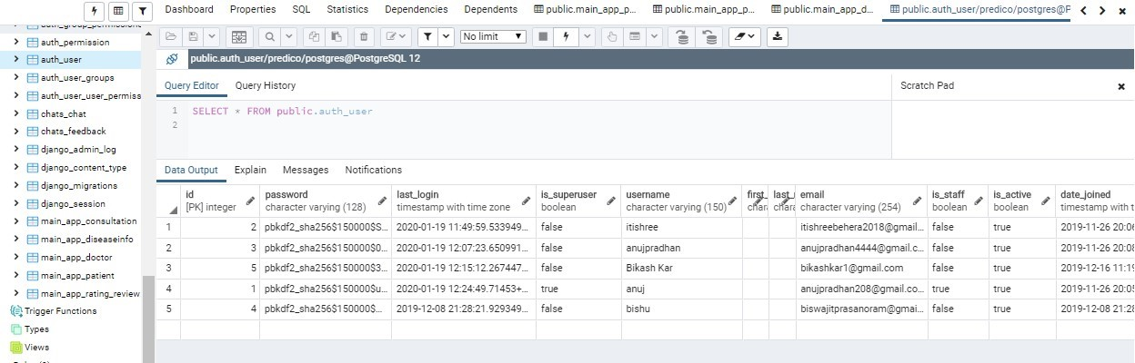

Patient table-

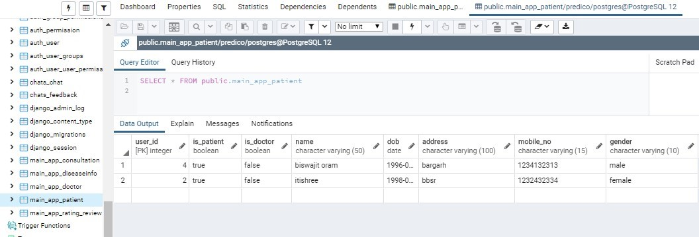

Consultation table-

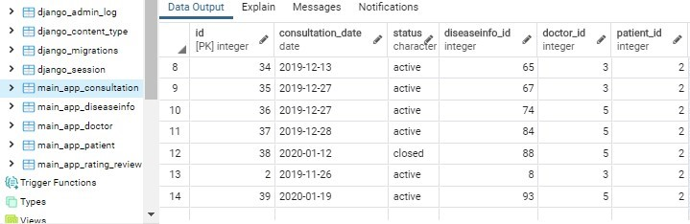

# References

Dahiwade, D., 2019. *ieeexplore.* [Online]   
Available at: https://ieeexplore.ieee.org/document/8819782  
[Accessed 15 08 2022].

geeksforgeeks, 2022. *geeksforgeeks.* [Online]   
Available at: https://www.geeksforgeeks.org/disease-prediction-using-machine-learning/

Hamilton, T., 2022. [Online]   
Available at: https://www.guru99.com/black-box-testing.html  
[Accessed 23 August 2022].

Hamilton, T., 2022. [Online]   
Available at: https://www.guru99.com/white-box-testing.html  
[Accessed 23 August 2022].

javatpoint, 2021. [Online]   
Available at: https://www.javatpoint.com/unit-testing  
[Accessed 23 August 2022].

kaggle, 2022. *kaggle.* [Online]   
Available at: https://www.kaggle.com/datasets/kaushil268/disease-prediction-using-machine-learning  
[Accessed 2022].

Priya, K. L., 2020. *ieeexplore.* [Online]   
Available at: https://ieeexplore.ieee.org/abstract/document/9142959  
[Accessed 15 08 2022].

Shetty, S. V., 2018. *ieeexplore.* [Online]   
Available at: https://ieeexplore.ieee.org/document/9002132  
[Accessed 15 08 2022].